CLUSTER ANALYSIS OF OBJECTIVELY MEASURED PHYSICAL ACTIVITY IN CHRONIC OBSTRUCTIVE PULMONARY DISEASE: A MULTICENTRIC CROSS-SECTIONAL STUDY

Rafael Mesquita^{1,2,}*, Gabriele Spina^{3,}*, Fabio Pitta⁴, David Donaire-Gonzalez⁵, Brenda M. Deering⁶, Mehul S. Patel⁷, Katy E. Mitchell⁸, Jennifer Alison⁹, Arnoldus J. R. van Gestel¹⁰, Stefanie Zogg¹¹, Philippe Gagnon¹², Beatriz Abascal-Bolado^{13,14}, Barbara Vagaggini¹⁵, Judith Garcia-Aymerich⁵, Kylie Hill^{16,17}, Elisabeth A. P. M. Romme¹⁸, Samantha S.C. Kon⁷, Paul S. Albert¹⁹, Benjamin Waschki²⁰, Dinesh Shrikrishna⁷, Sally J. Singh⁸, Nicholas S Hopkinson⁷, David Miedinger¹¹, Roberto P. Benzo¹⁴, François Maltais¹², Pierluigi Paggiaro¹⁵, Christine Jenkins²¹, Michael I. Polkey⁷, Sue C. Jenkins¹⁷, William D-C. Man⁷, Christian F. Clarenbach¹⁰, Nidia A. Hernandes⁴, Daniela Savi²², David R. Hillman²³, Karina C. Furlanetto⁴, Zoe J. McKeough²⁴, Sally Watts²⁴, Li W. Cindy Ng¹⁷, Diana Jarreta²⁵, Anne Kirsten²⁰, Dina Brooks¹⁶, Peter R. Eastwood²³, Thaís Sant'Anna⁴, Kenneth Meijer²⁶, Selina Dürr¹¹, Malcolm Kohler¹⁰, Vanessa S. Probst^{4,27}, Ruth Tal-Singer²⁸, Esther Garcia Gil²⁵, Jörg Leuppi¹¹, Peter M.A. Calverley¹⁹, Frank W. J. M. Smeenk¹⁸, Julie Yates²⁸, Richard W. Costello⁶, Marco Gramm²⁰, Roger Goldstein¹⁶, Helgo Magnussen²⁰, Emiel F.M. Wouters^{1,2}, Richard L. ZuWallack²⁹, Oliver Amft^{3,30,†}, Henrik Watz^{20,†}, and Martijn A. Spruit^{1,31,†}.
*Joint first authors †Joint senior authors

¹Department of Research & Education, CIRO+, center of expertise for chronic organ failure+, Horn, The Netherlands.
²Department of Respiratory Medicine, Maastricht University Medical Center+ (MUMC+), Maastricht, The Netherlands.
³ACTLab, Signal Processing Systems, TU Eindhoven, Eindhoven, The Netherlands.
⁴Laboratório de Pesquisa em Fisioterapia Pulmonar, Departamento de Fisioterapia, Universidade Estadual de Londrina (UEL), Londrina, Paraná, Brazil.
⁵Centre for Research in Environmental Epidemiology (CREAL), Barcelona, Spain.
⁶Department of Respiratory Medicine, Beaumont Hospital, Dublin, Ireland.
⁷NIHR Respiratory Biomedical Research Unit, Royal Brompton & Harefield NHS Foundation Trust and Imperial College, London, United Kingdom.
⁸NIHR CLAHRC-LNR Pulmonary Rehabilitation Research Group, University Hospitals, Leicester, United Kingdom.
⁹Physiotherapy Department, Royal Prince Alfred Hospital, Sydney, NSW, Australia.
¹⁰Pulmonary Division, University Hospital of Zurich, Zurich, Switzerland.
¹¹Internal Medicine, University Hospital of Basel, Basel, Switzerland.
¹²Centre de recherche, Institut Universitaire de cardiologie et de pneumologie de Québec, 2725 Chemin Ste-Foy Québec, Université Laval, Québec G1V 4G5, Canada.
¹³Division of Pulmonary. Hospital U. Marqués de Valdecilla. IFIMAV (Spain).
¹⁴Division of Pulmonary and Critical Care. Breathing and Behavior Laboratory. Mayo Clinic. Rochester, MN (USA).
¹⁵Cardio-Thoracic and Vascular Department, University of Pisa, Italy.
¹⁶Respiratory Medicine, West Park Healthcare Centre, Toronto, Canada.
¹⁷School of Physiotherapy and Curtin Health Innovation Research Institute, Curtin University, Perth, WA, Australia.
¹⁸Department of Respiratory Medicine, Catharina Hospital, Eindhoven, The Netherlands.
¹⁹School of Ageing and Chronic Disease, University Hospital Aintree, Liverpool, United Kingdom.
²⁰Pulmonary Research Institute at LungClinic Grosshansdorf, Airway Research Center North, Member of the German Centre for Lung Research, Grosshansdorf, Germany.
²¹Woolcock Institute of Medical Research, The University of Sydney, Camperdown, Australia.
²²Department of Pediatrics and Pediatric Neurology, Cystic Fibrosis Center, Sapienza University of Rome, Rome, Italy.
²³Department of Pulmonary Physiology, Sir Charles Gairdner Hospital, Perth, WA, Australia.
²⁴Clinical and Rehabilitation Sciences, The University of Sydney, Sydney, NSW, Australia.
²⁵R&D Centre, Almirall, Barcelona, Spain.
²⁶Department of Human Movement Science, Faculty of Health, Medicine and Life Sciences, Maastricht University, Maastricht, The Netherlands.
²⁷Centro de Pesquisa em Ciências da Saúde, Centro de Ciências Biológicas e da Saúde, Universidade Norte do Paraná (UNOPAR), Londrina, Paraná, Brazil.
²⁸GlaxoSmithKline, King of Prussia, PA, United States of America.
²⁹Department of Pulmonary and Critical Care, Saint Francis Hospital and Medical Center, Hartford, CT, United States of America.
³⁰Sensor Technology, University Passau, Germany.
³¹REVAL - Rehabilitation Research Center, BIOMED - Biomedical Research Institute, Faculty of Medicine and Life Sciences, Hasselt University, Diepenbeek, Belgium.

Financial support: RM is supported by CNPq, Conselho Nacional de Desenvolvimento Científico e Tecnológico – Brazil (246704/2012-8). Point-One funding from AgentschapNL, Dutch Ministry of Economic affairs, Netherlands. FOR CENTRES: please add here your own financial support, if there is any.

Correspondence:
Rafael Mesquita, MSc, PT
Department of Research & Education, CIRO+, center of expertise for chronic organ failure+; Hornerheide 1, 6085 NM, Horn, The Netherlands; Telephone number: +31 475 587 645; Email: rafaelmesquita14@ymail.com
ABSTRACT
Rationale: Reduced physical activity (PA) is related to important morbidity in chronic obstructive pulmonary disease (COPD). Detailed analyses of PA may provide relevant results, such as subgroups of subjects with distinct PA levels.
Objectives: To investigate PA levels and hourly patterns in patients with COPD, in terms of the heterogeneity after stratification for basic characteristics; differences in comparison to healthy subjects; and subgroups (clusters) of patients with different PA levels.
Methods: 1001 patients with COPD (65% men; median age, 67 yrs; median FEV_{1,} 49%pred.) from 10 different countries and 66 matched healthy subjects were cross-sectionally studied. PA levels and patterns were analyzed based on data from a multisensor armband. Cluster analysis of PA data was used to identify subgroups of subjects with different PA patterns.
Measurements and main results: Age, body mass index (BMI) and dyspnea grade, influenced PA levels and patterns in patients with COPD. Compared to healthy subjects, these patients presented distinct PA patterns. Five clusters were identified, each with distinct PA levels: 1, very inactive; 2, inactive; 3, somewhat inactive; 4, active; and 5, very active. Subjects from cluster 1 spent less time in moderate-to-vigorous intensity (15 (7 – 27) min∙day⁻¹) and more time in very light intensity (955 (904 – 1042) min∙day⁻¹) compared to other clusters, besides higher BMI and more dyspnea.
Conclusions: PA is a heterogeneous outcome in COPD, and subgroups of patients with distinct PA levels could be identified. These analyses may be useful for interventions aiming to promote PA in COPD.

Keywords: chronic obstructive pulmonary disease; physical activity; principal component analysis; cluster analysis.
INTRODUCTION

Patients with COPD have lower physical activity (PA) levels compared to healthy subjects,(1-3) which is related to higher risk of hospital admission and mortality.(4, 5) As PA levels can be used as outcome for clinical management, as well as a possible target for therapy, a greater awareness of the clinical importance of physical inactivity in COPD is needed amongst healthcare professionals and scientists.(REF_ERSStatementonPA_tobeincluded)

To date, most studies investigating PA levels in patients with COPD have reported relatively simplified analyses, presenting only the average daily level and its standard deviation.(6-9) Donaire-Gonzalez and colleagues(10) were the first to perform a more detailed analysis, showing that patients with COPD perform bouts of moderate-to-vigorous PA, and that the frequency of these bouts is inversely associated with the degree of airflow limitation.(10) Nevertheless, multiple other options are also available if the aim is to xxxxx, such as PA hourly patterns,(11) and even cluster analysis of PA levels.(11-14)

The analysis of PA hourly patterns can reveal whether specific physical activities are concentrated during certain periods of the day,(11) while cluster analysis is useful to identify subgroups of patients with similar PA profiles.(15) Such detailed analyses can provide a better insight in PA of patients with COPD, and may also be of clinical importance, as interventions thus far have failed to promote important increases in PA levels in patients with COPD.(16, 17)

To the best of our knowledge, PA hourly patterns and cluster analysis of PA levels have not been investigated in patients with COPD. Therefore, we aimed: 1) to describe the heterogeneity of PA levels and patterns in patients with COPD after stratifying for clinical characteristics; 2) to compare PA levels and patterns between patients with COPD and healthy subjects matched for gender, age and body mass index (BMI); 3) to identify clusters of patients with COPD based on PA levels; and 4) to investigate and compare clinical characteristics and PA levels and patterns between these clusters.

METHODS

Study design and participants
In this multicentric, cross-sectional study, a secondary analysis of objectively assessed PA data from 10 different countries was performed. Researchers/clinicians from the United Kingdom (UK), Ireland, the Netherlands, Germany, Switzerland, Italy, Spain, the United States of America (USA), Brazil and Australia with published and/or unpublished PA data (with no overlapping analysis) as assessed by the activity monitor SenseWear Armband or SenseWear Mini Armband (both from BodyMedia Inc., Pittsburgh, PA, USA) were invited to share their data for the current analysis. References of previously published data can be found in the online supplement, as well as the number of subjects included from each country (Table E1). Subjects were included if they presented: COPD with a post-bronchodilator forced expiratory volume in the first 1 s (FEV₁) / forced vital capacity (FVC) ratio <0.7(18), stable condition (i.e., no recent exacerbation), and complete data for age, gender, BMI and daily PA levels (see Physical activity assessment section for details). All studies were approved by the local medical ethical committees, and written informed consent was obtained from participants, except for the data from Italy (n=23), which were obtained as part of routine clinical assessments.

Demographics, anthropometrics, lung function, and clinical data were collected: age, gender, BMI (weight in kg per squared height in m),(19) FEV₁ (% of predicted), FEV₁/FVC ratio, diffusion capacity of the lung for carbon monoxide (D_{LCO}, % of predicted), symptoms of dyspnea by the modified Medical Research Council (mMRC) dyspnea grade,(20) use of walking aids (yes/no), and use of long-term oxygen therapy (LTOT, yes/no). In addition, subjects were stratified by BMI (underweight (<18.5 kg∙m⁻²), normal weight (18.5 to 24.99 kg∙m⁻²), pre-obese (25 to 29.99 kg∙m⁻²), or obese (≥ 30 kg∙m⁻²))(21) and GOLD grades (1 to 4).(18)

Centers from the Netherlands and the UK also had available a sample of healthy elderly subjects and were invited to share these data for the current analysis. The healthy subjects were pairwise-matched (i.e., 1:1) for gender, age and BMI with selected patients with COPD.

Physical activity assessment
The SenseWear Armband and SenseWear Mini Armband activity monitors (both from BodyMedia Inc., Pittsburgh, PA, USA) were used for the assessment of PA. These devices combine an accelerometer with different physiological sensors (i.e., a heat flux sensor, a galvanic skin response sensor, a skin temperature sensor, and a near-body ambient temperature sensor). Together with demographic characteristics, such as gender, age, height and weight, energy expenditure (EE) can be estimated using proprietary algorithms developed by the manufacturer. The SenseWear Armband has been shown to be valid in both field(22, 23) and laboratory studies.(24-26) The following thresholds proposed by the American College of Sports Medicine (ACSM)(27) were used to classify the intensity of activities: very light intensity, <2.0 metabolic equivalents of task (MET); light intensity, 2.0 to 2.9 METs; and moderate-to-vigorous intensity, ≥3.0 METs.

A minimum of 4 days (2 weekdays + Saturday + Sunday) was considered acceptable,(6) with the device being used for ≥22 hours.(28) Since PA levels during week and weekend are known to be different,(6) for the cluster analysis only recordings during waking hours and weekdays were considered, in order to reduce the variability of the data. The recordings represent the average of all valid weekdays. Weekend days were used only for the presentation of daily hourly patterns. The software SenseWear Professional versions 6.1 and 7.0 were used for data analysis, providing minute-by-minute EE and METs. These two features were stratified according to different criteria (and the combination of them), using Matlab R2012b (Mathworks Inc., USA): intensity (e.g., very light, light or moderate-to-vigorous intensity), duration (e.g., bouts of activity), period of the day (e.g., before or after midday), frequency (e.g., number of bouts per day); and presentation (e.g., absolute numbers or percentage of total). These stratifications led to distinct 180 features (Table E2, online supplement), which were used for clustering the patients.

In our study, the features collected from the software are referred as PA levels, while the term PA pattern is used in reference to the graphic representation of the median intensity of PA per hour during a day averaged over all valid days.

Statistical Analysis
Continuous variables were expressed as median (interquartile range), as most variables presented non-normal distribution. Categorical variables were expressed as absolute and/or relative frequency. Mann-Whitney U test or Kruskal-Wallis test (followed by Dunn’s test) was used for the comparison of continuous variables, while the chi-square test was used for categorical variables. Spearman coefficient was used to investigate correlations, when appropriate. P< .05 was considered significant and all statistical analyses were performed using SPSS 17.0 (SPSS, Chicago, Illinois, USA) or GraphPad Prism 5 (GraphPad Software, La Jolla, California, USA).

Cluster analysis was adopted to identify groups of patients with distinct PA levels/patterns??. Firstly, the 180 features generated after stratification of EE and METs were subjected to factor analysis, used for data reduction. As additive relationship was evident among some features, Principal Component Analysis (PCA) was used to project the high-dimensional feature set (180 dimensions) to a lower dimensional subspace useful for data visualization (3 dimensions). By extracting orthogonal axes of variance, PCA transforms the data into a set of values of linearly uncorrelated variables called principal components and arranges them in order of relative significance. Each feature is used for the computation of every principal component. Secondly, a k-mean clustering algorithm with automatic selection of the number of clusters(29) was applied to the reduced feature space (first 3 PCA components), in order to partition the patients in cluster with similar characteristics. The features were first standardized using z-scores. Feature extraction, PCA and clustering analyses were performed using Matlab R2012b (Mathworks Inc., USA).

RESULTS

General characteristics
In total, 1001 patients with COPD were analyzed (Table 1). The majority of the patients included in the analysis were men, presented moderate-to-severe degree of airflow limitation, and only a small proportion used LTOT and/or walking aids.

Daily physical activity levels and patterns
The median number of valid days (i.e., ≥22 hours) was 6 (6 – 6) days, resulting in a total of 6074 valid PA days, of which 4049 (67%) were weekdays. PA assessments took place in summer (n=264, 26%), autumn (n=333, 33%), winter (n=229, 23%), or spring (n=175, 18%).

Table 2 presents the daily PA levels during weekdays. The smallest amounts of time and EE were spent in moderate-to-vigorous intensity. Considering this intensity, patients spent a median of 6 (0 – 22) min·day⁻¹ in bouts of ≥10 minutes and 38 (17 – 79) min·day⁻¹ in bouts of ≥2 minutes. Figure 1 presents the daily hourly pattern of the patients during weekdays and weekend days. A similar pattern can be observed between weekdays and weekend days, and in both analyses the peak of intensity occurred before midday.

Stratification for clinical characteristics
Patients of older age, female gender, LTOT users, walking aid users, lower DLCO, higher mMRC dyspnea grade, higher BMI and higher GOLD grade spent less time and EE in moderate-to-vigorous intensity (Tables E3-E10, online supplement). Figure 2 presents the daily hourly patterns after stratification for the abovementioned clinical characteristics, showing an obvious influence of BMI, mMRC dyspnea grade, and the use of walking aids. The influence of GOLD grades on the patterns was apparently small. Indeed, a weak but significant positive association between the degree of airflow limitation and the time in moderate-to-vigorous intensity was observed (r_{s}=0.20, P<0.0001; Figure 3).

COPD versus healthy subjects
Table 3 presents the general characteristics and daily PA levels in moderate-to-vigorous intensity of healthy subjects and a subgroup of patients with COPD, pairwise-matched for gender, age and BMI. In total, 66 healthy subjects were included and analyzed. As expected, subjects with COPD presented worse lung function, higher dyspnea and lower PA levels compared to healthy subjects. The comparison of daily PA levels in very light and light intensities can be found in Table E11 (online supplement). Interestingly, patients with COPD spent more time in very light intensity than healthy subjects, but there was no difference for the time in light intensity. Figure 4 presents the daily hourly pattern of the groups. Both groups presented the peak of intensity before midday. The pattern during weekdays and weekend days was relatively similar in the COPD sample, but not in the sample of healthy subjects, in which the peak of intensity during the day tended to be lower on weekends.

Cluster analysis of daily PA levels
Five clusters were identified based on 3 components from the PCA (Figure 5; see online supplement for the 3D video of Figure 5). The most relevant features of the 1st component involved ≥2-min and ≥10-min bouts of very light intensity, the most relevant of the 2nd component involved the total daily EE in moderate-to-vigorous intensity and the daily EE in ≥2-min and ≥10-min bouts of moderate-to-vigorous intensity, while the most relevant of the 3rd component involved the total daily EE in very light intensity and the daily EE in ≥2-min bouts of very light intensity. Table 4 presents the general characteristics and PA levels in moderate-to-vigorous intensity of the clusters. Cluster 4 (active) and 5 (very active) were characterized by remarkable amounts of time and EE in moderate-to-vigorous intensity. In fact, these two clusters spent more time and EE than clusters 1 (very inactive), 2 (inactive) and 3 (somewhat inactive). PA levels in very light and light intensities can be found in Table E12 (online supplement). In general, clusters 1 and 2 (very inactive and inactive, respectively) spent more time and EE in very light intensity (a surrogate of sedentary activities) than other clusters. The smallest amounts of time and EE in light intensity were spent by cluster 1. Regarding general characteristics, cluster 1 (very inactive) was older than cluster 4 (active), had lower FEV₁ compared to clusters 3 and 4 (somewhat inactive and active, respectively) and higher BMI and mMRC grade compared to all the other clusters. Similarly, cluster 2 (inactive) was older than cluster 4 (active), had higher BMI compared to this cluster, lower FEV₁ and higher mMRC grade compared to cluster 3 (somewhat inactive), and higher mMRC grade compared to cluster 5 (very active). Figure 6 presents the daily hourly pattern of the clusters, and in all clusters the peak of intensity during the day occurred before midday. In general, the pattern during weekdays and weekend days was similar.

DISCUSSION

The present study provides detailed analyzes of PA in a multinational sample of 1001 patients with COPD. The present analyses showed that: 1) daily PA levels and patterns are very heterogeneous amongst patients with COPD and importantly influenced by age, BMI, and mMRC dyspnea grade; 2) patients with COPD present not only lower PA levels, but also distinct PA patterns in comparison to healthy subjects; and 3) patients with COPD can be clustered based on their daily PA levels, with 5 clusters being identified, each with very distinct PA levels and patterns. Importantly, a subgroup of patients with importantly reduced PA levels was observed (i.e., cluster 1, very inactive).

Heterogeneity in daily PA levels and patterns
Our results clearly show that PA is a very heterogeneous outcome, corroborating previous findings.(1, 30, 31) Distinct daily PA levels were found after stratification for age, gender, BMI, mMRC dyspnea grade, LTOT, use of walking aids, DLCO, and GOLD grade (Tables E3-E10). Most of these clinical characteristics have been recently investigated as determinants and/or outcomes of PA in a systematic review by Gimeno-Santos et al.(32) Despite based on cross-sectional studies and low-quality evidence, in general, most of the results found by these authors are corroborated by our findings. The only clinical characteristic not investigated in their study was the use of walking aids. We found that subjects using walking aids spent less time in moderate-to-vigorous intensity than those not using these devices (Table E8). Patients who need walking aids tend to be frailer, and in fact in our study we found lower FEV₁ and higher mMRC grade in these subjects compared to their counterparts (results not shown). Nevertheless, this can also represents a limitation of the SenseWear Armband in properly capturing PA levels when the arm is moving less, due to the use of walking aids.(25) Only BMI, mMRC dyspnea grade, and the use of walking aids seem to considerably affect PA hourly patterns (Figure 2). High BMI and more dyspnea can clearly work as physical constraints for a more physically active lifestyle, but the use of walking aid should work as a facilitator instead. Nevertheless, this fact can be explained by differences in clinical characteristics and limitations of the device used, as previously mentioned. The stratification for GOLD grades seems to have less influence on PA patterns, and this is supported by a weak association between measures of lung function and PA found in our study (Figure 3), but also reported in previous researches.(1, 6, 7)

Daily PA levels and patterns in healthy subjects and patients with COPD
Several studies have already shown that patients with COPD are less physically active compared to healthy subjects.(1, 3, 28) The present study is the first to confirm this finding after an exact matching for gender, age and BMI. This is probably the first study to also show that patients with COPD not only spend less time in moderate-to-vigorous intensity, but also more time in very light intensity, which can be assumed as a surrogate of sedentary time (i.e., activities between 1.0-1.5 METs).(33) Previously, studies have shown that some subjects can be considered physically active, but still present considerable amounts of time in very light intensities.(33) In patients with COPD, most previous studies have used variables related to activities of high intensity (e.g. time in moderate-to-vigorous intensity) to evidence the inactivity of these patients,(6, 10, 34) and this can produce incomplete results. Reducing the time in very light intensity without necessarily increasing the time in moderate-to-vigorous intensity can be an important strategy in patients with COPD, especially in those with very low PA levels. Distinct PA hourly patterns were found in patients with COPD in comparison to healthy subjects, and this has not been shown before. Patients with COPD develop their activities at a lower intensity compared to healthy subjects, and this difference is more evident during weekdays. In fact, a more similar pattern between weekdays and weekend days was found in patients with COPD, but not in healthy subjects.

Clusters of patients with COPD based on daily PA levels
The present study is the first to cluster patients with COPD based on daily PA levels, emphasizing again the heterogeneity of daily PA levels in this population. Indeed, five clusters were identified, each with distinct PA levels. One very active and one very inactive cluster were identified, but clusters with intermediate PA levels were also observed. The very inactive cluster (i.e., cluster 1) not only spent less time in moderate-to-vigorous intensity (Table 4), but also more time in very light intensity (Table E12), besides a very similar pattern between weekdays and weekend days.

Few studies have used objectively measured daily PA levels solely for clustering subjects, but in populations other than patients with COPD, such as children and middle-aged adults. In 10-to-12-year-old children, De Bourdeaudhuij and colleagues(35) were able to identify four clusters in each gender group, based on the time in activities of moderate-to-vigorous intensity and in sedentary activities. Besides clusters with very distinct PA levels (e.g., active or inactive), these authors also found one cluster with a mixed pattern (i.e., less time in moderate-to-vigorous intensity + less sedentary time), confirming that activities of moderate-to-vigorous intensity and sedentary activities are not two sides of one continuum.(35) None of the clusters found in our study presented such a pattern, instead they tended to present more distinctive arrangements (i.e., active or inactive). An active and a very active cluster were identified in our study (i.e., clusters 4 and 5, respectively), and these two clusters met the recommendation of ≥30 minutes (in ≥10-min bouts) in activities of moderate-to-vigorous intensity.(27) On the other hand, an inactive and a very inactive cluster were also found (i.e., clusters 2 and 1, respectively), and less time in moderate-to-vigorous intensity and more time in very light intensity were spent by these clusters compared to other clusters (Tables 4 and E12), suggesting that these clusters are truly physically inactive. Encouragement should be given to spend more time in activities of moderate-to-vigorous intensity, but also to reduce the time in sedentary activities. Based on their low PA levels, patients from these clusters must probably have a worse prognosis,(4, 5) but no follow-up data is available to confirm this hypothesis. In middle-aged Chinese adults, based on average counts per minute Lee et al.(11) identified two clusters, one more active than the other. Male subjects from the less active cluster presented higher body fat percentage and older age than those from the active group.(11) In our study, patients from the very inactive cluster (i.e., cluster 1) presented older age, lower FEV₁, higher BMI and worse dyspnea compared to other clusters, and these findings may explain, at least in part, the physical inactivity of these patients. Nonetheless, as previous studies have found important associations between PA and determinants other than these,(30-32) we believe that other factors might also be involved.

In one of the few studies investigating PA hourly patterns, Lee et al.(11) observed that the less active cluster presented a smoother PA pattern with lower intensities, and that this pattern was similarly found in both weeks and weekends.(11) The active cluster in their study presented distinct patterns between weeks and weekends.(11) Our results support these findings by showing that the more inactive a cluster is, the more similar is its PA pattern between weeks and weekends.

Strengths and limitations of the findings
Our sample is by far the largest multicentric sample of patients with COPD with objectively assessed PA data ever studied. So far, only three studies have studied PA levels in multicentric samples of patients with COPD,(28, 34, 36) but all with samples much smaller than the one currently studied. This allowed a deeper analysis of daily PA, even identifying subgroups of subjects with different PA levels, a true novelty within the COPD literature. PA hourly patterns were also investigated for the first time in COPD, another important advance. All these analyses were only possible due to the use of objective methods of PA, another strength in our study.

This study also has some methodological limitations. We used a cross-sectional design, and a longitudinal study would be important both to check associations with relevant outcomes, such as mortality, and to investigate the stability of the clusters over time. We believe that subjects from one cluster may migrate to another cluster along the time. The replication of our findings in an external cohort would also be relevant to validate our findings. All these points should be addressed in future studies. “traditional limitations“ are missing: sleection bias, information bias and confoundng, + external validity

This study has truly advanced our understanding of daily PA in patients with COPD. In a large and multicentric sample we were able to show that not only levels, but also patterns of PA are distinct after stratification for basic characteristics and when compared to appropriately matched healthy subjects. Five clusters of patients were identified based on PA levels, each with very characteristic PA levels and patterns (from a very inactive to a very active cluster). Compared to other cluster, the very inactive clusters spent less time in higher intensities and more time in lower intensities, besides presenting a higher BMI and more dyspnea, characteristics related to a worse prognosis. Interventions aiming to promote PA in patients with COPD may be more effective if PA levels and patterns are investigates in details, as done in the current study.
ACKNOWLEDGEMENTS

FOR CENTRES: Please add here your own acknowledgements, if there is any.
REFERENCES

1. Pitta F, Troosters T, Spruit MA, Probst VS, Decramer M, Gosselink R. Characteristics of physical activities in daily life in chronic obstructive pulmonary disease. Am J Respir Crit Care Med 2005;171:972-977.
2. Sandland CJ, Singh SJ, Curcio A, Jones PM, Morgan MD. A profile of daily activity in chronic obstructive pulmonary disease. J Cardiopulm Rehabil 2005;25:181-183.
3. Walker PP, Burnett A, Flavahan PW, Calverley PM. Lower limb activity and its determinants in copd. Thorax 2008;63:683-689.
4. Garcia-Aymerich J, Lange P, Benet M, Schnohr P, Anto JM. Regular physical activity reduces hospital admission and mortality in chronic obstructive pulmonary disease: A population based cohort study. Thorax 2006;61:772-778.
5. Waschki B, Kirsten A, Holz O, Muller KC, Meyer T, Watz H, Magnussen H. Physical activity is the strongest predictor of all-cause mortality in patients with copd: A prospective cohort study. Chest 2011;140:331-342.
6. Watz H, Waschki B, Meyer T, Magnussen H. Physical activity in patients with copd. Eur Respir J 2009;33:262-272.
7. Pitta F, Takaki MY, Oliveira NH, Sant'anna TJ, Fontana AD, Kovelis D, Camillo CA, Probst VS, Brunetto AF. Relationship between pulmonary function and physical activity in daily life in patients with copd. Respir Med 2008;102:1203-1207.
8. Hill K, Dolmage TE, Woon L, Coutts D, Goldstein R, Brooks D. Defining the relationship between average daily energy expenditure and field-based walking tests and aerobic reserve in copd. Chest 2012;141:406-412.
9. Depew ZS, Karpman C, Novotny PJ, Benzo RP. Correlations between gait speed, 6-minute walk distance, physical activity, and self-efficacy in patients with severe chronic lung disease. Respir Care 2013;58:2113-2119.
10. Donaire-Gonzalez D, Gimeno-Santos E, Balcells E, Rodriguez DA, Farrero E, de Batlle J, Benet M, Ferrer A, Barbera JA, Gea J, et al. Physical activity in copd patients: Patterns and bouts. Eur Respir J 2013;42:993-1002.
11. Lee PH, Yu YY, McDowell I, Leung GM, Lam TH. A cluster analysis of patterns of objectively measured physical activity in hong kong. Public Health Nutr 2013;16:1436-1444.
12. Trilk JL, Pate RR, Pfeiffer KA, Dowda M, Addy CL, Ribisl KM, Neumark-Sztainer D, Lytle LA. A cluster analysis of physical activity and sedentary behavior patterns in middle school girls. J Adolesc Health 2012;51:292-298.
13. Gubbels JS, Kremers SP, Stafleu A, Goldbohm RA, de Vries NK, Thijs C. Clustering of energy balance-related behaviors in 5-year-old children: Lifestyle patterns and their longitudinal association with weight status development in early childhood. Int J Behav Nutr Phys Act 2012;9:77.
14. Bussmann JB, van den Berg-Emons RJ. To total amount of activity..... And beyond: Perspectives on measuring physical behavior. Front Psychol 2013;4:463.
15. Wardlaw AJ, Silverman M, Siva R, Pavord ID, Green R. Multi-dimensional phenotyping: Towards a new taxonomy for airway disease. Clin Exp Allergy 2005;35:1254-1262.
16. Cindy Ng LW, Mackney J, Jenkins S, Hill K. Does exercise training change physical activity in people with copd? A systematic review and meta-analysis. Chron Respir Dis 2012;9:17-26.
17. Steele BG, Belza B, Cain KC, Coppersmith J, Lakshminarayan S, Howard J, Haselkorn JK. A randomized clinical trial of an activity and exercise adherence intervention in chronic pulmonary disease. Arch Phys Med Rehabil 2008;89:404-412.
18. Vestbo J, Hurd SS, Agusti AG, Jones PW, Vogelmeier C, Anzueto A, Barnes PJ, Fabbri LM, Martinez FJ, Nishimura M, et al. Global strategy for the diagnosis, management, and prevention of chronic obstructive pulmonary disease: Gold executive summary. Am J Respir Crit Care Med 2013;187:347-365.
19. Keys A, Fidanza F, Karvonen MJ, Kimura N, Taylor HL. Indices of relative weight and obesity. J Chronic Dis 1972;25:329-343.
20. Bestall JC, Paul EA, Garrod R, Garnham R, Jones PW, Wedzicha JA. Usefulness of the medical research council (mrc) dyspnoea scale as a measure of disability in patients with chronic obstructive pulmonary disease. Thorax 1999;54:581-586.
21. Spruit MA, Singh SJ, Garvey C, Zuwallack R, Nici L, Rochester C, Hill K, Holland AE, Lareau SC, Man WD, et al. An official american thoracic society/european respiratory society statement: Key concepts and advances in pulmonary rehabilitation. Am J Respir Crit Care Med 2013;188:e13-64.
22. Colbert LH, Matthews CE, Havighurst TC, Kim K, Schoeller DA. Comparative validity of physical activity measures in older adults. Med Sci Sports Exerc 2011;43:867-876.
23. Mackey DC, Manini TM, Schoeller DA, Koster A, Glynn NW, Goodpaster BH, Satterfield S, Newman AB, Harris TB, Cummings SR. Validation of an armband to measure daily energy expenditure in older adults. J Gerontol A Biol Sci Med Sci 2011;66:1108-1113.
24. Furlanetto KC, Bisca GW, Oldemberg N, Sant'anna TJ, Morakami FK, Camillo CA, Cavalheri V, Hernandes NA, Probst VS, Ramos EM, et al. Step counting and energy expenditure estimation in patients with chronic obstructive pulmonary disease and healthy elderly: Accuracy of 2 motion sensors. Arch Phys Med Rehabil 2010;91:261-267.
25. Hill K, Dolmage TE, Woon L, Goldstein R, Brooks D. Measurement properties of the sensewear armband in adults with chronic obstructive pulmonary disease. Thorax 2010;65:486-491.
26. Cavalheri V, Donaria L, Ferreira T, Finatti M, Camillo CA, Cipulo Ramos EM, Pitta F. Energy expenditure during daily activities as measured by two motion sensors in patients with copd. Respir Med 2011;105:922-929.
27. Garber CE, Blissmer B, Deschenes MR, Franklin BA, Lamonte MJ, Lee IM, Nieman DC, Swain DP. American college of sports medicine position stand. Quantity and quality of exercise for developing and maintaining cardiorespiratory, musculoskeletal, and neuromotor fitness in apparently healthy adults: Guidance for prescribing exercise. Med Sci Sports Exerc 2011;43:1334-1359.
28. Waschki B, Spruit MA, Watz H, Albert PS, Shrikrishna D, Groenen M, Smith C, Man WD, Tal-Singer R, Edwards LD, et al. Physical activity monitoring in copd: Compliance and associations with clinical characteristics in a multicenter study. Respir Med 2012;106:522-530.
29. von Luxburg U. Clustering stability: An overview. Foundations and trends in machine learning 2010;2:235-274.
30. Watz H, Waschki B, Boehme C, Claussen M, Meyer T, Magnussen H. Extrapulmonary effects of chronic obstructive pulmonary disease on physical activity: A cross-sectional study. Am J Respir Crit Care Med 2008;177:743-751.
31. Garcia-Aymerich J, Serra I, Gomez FP, Farrero E, Balcells E, Rodriguez DA, de Batlle J, Gimeno E, Donaire-Gonzalez D, Orozco-Levi M, et al. Physical activity and clinical and functional status in copd. Chest 2009;136:62-70.
32. Gimeno-Santos E, Frei A, Steurer-Stey C, de Batlle J, Rabinovich RA, Raste Y, Hopkinson NS, Polkey MI, van Remoortel H, Troosters T, et al. Determinants and outcomes of physical activity in patients with copd: A systematic review. Thorax.
33. Pate RR, O'Neill JR, Lobelo F. The evolving definition of "Sedentary". Exerc Sport Sci Rev 2008;36:173-178.
34. Troosters T, Sciurba F, Battaglia S, Langer D, Valluri SR, Martino L, Benzo R, Andre D, Weisman I, Decramer M. Physical inactivity in patients with copd, a controlled multi-center pilot-study. Respir Med 2010;104:1005-1011.
35. De Bourdeaudhuij I, Verloigne M, Maes L, Van Lippevelde W, Chinapaw MJ, Te Velde SJ, Manios Y, Androutsos O, Kovacs E, Dossegger A, et al. Associations of physical activity and sedentary time with weight and weight status among 10- to 12-year-old boys and girls in europe: A cluster analysis within the energy project. Pediatr Obes 2013;8:367-375.
36. Pitta F, Breyer MK, Hernandes NA, Teixeira D, Sant'Anna TJ, Fontana AD, Probst VS, Brunetto AF, Spruit MA, Wouters EF, et al. Comparison of daily physical activity between copd patients from central europe and south america. Respir Med 2009;103:421-426.

FIGURE LEGENDS

TO BE INCLUDED.
TABLES

TABLE 1. CHARACTERISTICS OF PATIENTS WITH COPD (n=1001)
Characteristic | Value
Age, yrs | 67 (61 – 72)
Male, n (%) | 654 (65)
Weight, kg | 74 (62 – 87)
Height, m | 1.70 (1.63 – 1.75)
BMI, kg·m⁻² | 25.8 (22.5 – 29.6)
BMI classification, %  Underweight  Normal weight  Overweight  Obese | 7  37  34  22
mMRC dyspnea grade* | 2 (1 – 3)
Long-term oxygen therapy, n / %† | 67 / 10
Walking aid, n / %‡ | 19 / 3
FEV₁, L | 1.31 (0.91 – 1.79)
FEV₁, % predicted | 49 (34 – 64)
FEV₁/FVC, % | 45 (35 – 56)
DLCO, % predicted§ | 51 (37 – 67)
GOLD grade 1/2/3/4, % | 9 / 40 / 34 / 17
Data expressed as absolute and relative frequency or median (interquartile range). BMI: body mass index; mMRC: modified Medical Research Council; FEV₁: forced expiratory volume in the first second; FVC: forced vital capacity; DLCO: diffusion capacity of the lung for carbon monoxide; GOLD: Global Initiative for Chronic Obstructive Lung Disease. *Data available for 868 subjects; †Data available for 707 subjects; ‡Data available for 705 subjects; §Data available for 505 subjects.
TABLE 2. DAILY PHYSICAL ACTIVITY LEVELS DURING WEEKDAYS IN PATIENTS WITH COPD
 | General physical activity
Feature | Very light intensity | Light intensity | Moderate-to-vigorous intensity
Time, min∙day⁻¹  Before midday  After midday  Total | 283 (236 – 347)  514 (449 – 577)‡  803 (710 – 901) | 49 (31 – 74)*  88 (53 – 123)*,‡  142 (92 – 194)* | 21 (10 – 42)*,†  27 (13 – 59)*,†,‡  52 (26 – 99)*,†
EE, METs-min∙day⁻¹  Before midday  After midday  Total | 364 (274 – 502)  668 (521 – 858)‡  1032 (822 – 1327) | 154 (95 - 263)*  273 (167 – 413)*,‡  435 (291 – 655)* | 110 (46 – 232)*,†  147 (65 – 310)*,†,‡  267 (132 – 550)*,†
 | Bouts of physical activity
Feature | Very light intensity | Light intensity | Moderate-to-vigorous intensity
Time, min∙day⁻¹  ≥2-minute  Before midday  After midday  Total  ≥10-minute  Before midday  After midday  Total | 273 (225 – 338)  503 (435 – 569)‡  781 (683 – 884)  215 (167 – 284)  436 (352 – 526)‡  657 (539 – 780) | 37 (22 – 59)*  67 (37 – 97)*,‡  107 (65 – 156)*  3 (0 – 8)*  4 (0 – 14)*,‡  7 (0 – 22)* | 15 (6 – 34)*,†  20 (8 – 47)*,†,‡  38 (17 – 79)*,†  2 (0 – 11)*  3 (0 – 13)*,†,‡  6 (0 – 22)*
Frequency, bouts∙day⁻¹  ≥2-minute  Before midday  After midday  Total  ≥10-minute  Before midday  After midday  Total | 21 (17 – 25)  27 (21 – 34)‡  48 (39 – 58)  7 (6 – 9)  11 (9 – 13)‡  18 (16 – 21) | 11 (7 – 16)*  19 (11 – 26)*,‡  31 (20 – 41)*  0 (0 – 1)*  0 (0 – 1)*,‡  1 (0 – 2)* | 4 (2 – 8)*,†  5 (2 – 10)*,†,‡  10 (5 – 17)*,†  0 (0 – 1)*  0 (0 – 1)*,‡  1 (0 – 2)*
Average duration, min∙bout⁻¹  ≥2-minute  Before midday  After midday  Total  ≥10-minute  Before midday  After midday  Total | 13 (10 – 17)  18 (13 – 27)‡  16 (12 – 21)  29 (24 – 36)  37 (29 – 50)‡  34 (28 – 43) | 3 (3 – 4)*  3 (3 – 4)*  3 (3 – 4)*  10 (0 – 13)*  11 (0 – 13)*,‡  12 (0 – 14)* | 4 (3 – 5)*,†  4 (3 – 5)*,†  4 (3 – 5)*,†  10 (0 – 15)*,†  11 (0 – 15)*  13 (0 – 16)*,†
EE, METs-min∙day⁻¹  ≥2-minute  Before midday  After midday  Total  ≥10-minute  Before midday  After midday  Total | 347 (261 – 490)  648 (501 – 845)‡  1000 (783 – 1298)  273 (193 – 411)  572 (410 – 783)‡  847 (626 – 1168) | 118 (67 – 205)*  211 (119 – 335)*,‡  340 (204 – 523)*  6 (0 – 26)*  14 (0 – 47)*,‡  26 (0 – 77)* | 86 (29 – 187)*,†  106 (41 – 255)*,†,‡  205 (86 – 436)*,†  9 (0 – 61)*,†  12 (0 – 69)*,‡  36 (0 – 132)*
Data expressed as median (interquartile range). EE: energy expenditure; MET: metabolic equivalent of task. *P<0.05 vs very light intensity; †P<0.05 vs light intensity; ‡P<0.05 vs before midday.
TABLE 3. GENERAL CHARACTERISTICS AND DAILY PHYSICAL ACTIVITY LEVELS IN MODERATE-TO-VIGOROUS INTENSITY IN HEALTHY SUBJECTS AND MATCHED PATIENTS WITH COPD
Characteristics and features | Healthy subjects | Matched patients with COPD | P-value
General characteristics  N | 66 | 66
Age, yrs | 65 (61 – 70) | 65 (61 – 70) | 1.00
Male, % | 45 | 45 | 1.00
BMI, kg·m⁻² | 25.3 (22.9 – 28.1) | 24.9 (22.4 – 27.9) | 0.65
FEV₁, % predicted | 107 (97 – 117) | 43 (29 – 63) | <0.0001
FEV₁/FVC, % | 78 (75 – 82) | 42 (32 – 54) | <0.0001
mMRC dyspnea grade, points* | 0 (0 – 0) | 2 (1 – 3) | <0.0001
Physical activity levels in moderate-to-vigorous intensity  Time, min∙day⁻¹ | 101 (57 – 163) | 47 (30 – 95) | <0.0001
EE, METs-min∙day⁻¹ | 461 (271 – 797) | 213 (123 – 435) | <0.0001
Time in ≥2-min bouts, min∙day⁻¹ | 82 (38 – 138) | 37 (15 – 83) | <0.0001
Time in ≥10-min bouts, min∙day⁻¹ | 29 (10 – 73) | 6 (0 – 20) | <0.0001
Frequency of ≥2-min bouts, bouts∙day⁻¹ | 17 (10 – 25) | 9 (5 – 17) | <0.0001
Frequency of ≥10-min bouts, bouts∙day⁻¹ | 2 (1 – 4) | 0 (0 – 1) | <0.0001
Average duration of ≥2-min bouts, min∙bout⁻¹ | 5 (4 – 7) | 4 (3 – 5) | <0.0001
Average duration of ≥10-min bouts, min∙bout⁻¹ | 16 (13 – 21) | 12 (0 – 14) | <0.0001
EE in ≥2-min bouts, METs-min∙day⁻¹ | 362 (212 – 712) | 164 (65 – 376) | <0.0001
EE in ≥10-min bouts, METs-min∙day⁻¹ | 107 (47 – 417) | 23 (0 – 121) | <0.0001
Data expressed as median (interquartile range). See Tables 1 and 2 for definition of abbreviations. *Data missing for 18 healthy subjects and 7 patients with COPD.

TABLE 4. GENERAL CHARACTERISTICS AND DAILY PHYSICAL ACTIVITY LEVELS IN MODERATE-TO-VIGOROUS INTENSITY OF CLUSTERS OF PATIENTS WITH COPD
Characteristics and features | Cluster 1  (very inactive) | Cluster 2  (inactive) | Cluster 3  (somewhat inactive) | Cluster 4  (active) | Cluster 5  (very active) | P-value
General characteristics  N | 216 | 415 | 184 | 165 | 21
Age, yrs | 68 (62 – 74) | 67 (61 – 72) | 67 (60 – 72) | 63 (58 – 70)†,‡ | 63 (56 – 68) | <0.0001
Male, % | 67 | 67 | 51 | 76 | 67 | 0.32
BMI, kg·m⁻² | 30.4 (26.5 – 34.7) | 25.7 (22.6 – 29.0)† | 24.9 (22.2 – 27.4)† | 23.1 (20.3 – 26.8)†,‡ | 22.5 (18.3 – 30.9)† | <0.0001
FEV₁, % predicted | 44 (32 – 58) | 48 (34 – 61) | 57 (41 – 71)†,‡ | 50 (36 – 68)† | 51 (39 – 70) | <0.0001
FEV₁/FVC, % | 43 (34 – 55) | 44 (34 – 55) | 50 (38 – 61)†,‡ | 47 (36 – 57) | 49 (38 – 64) | 0.002
mMRC dyspnea grade, points* | 2 (1 – 3) | 2 (1 – 3)† | 1 (1 – 2)†,‡ | 1 (0 – 3)† | 1 (0 – 2)†,‡ | <0.0001
Physical activity levels in moderate-to-vigorous intensity  Time, min∙day⁻¹ | 15 (7 – 27) | 48 (30 – 70)† | 68 (43 – 96)†,‡ | 166 (136 – 219)†,‡,§ | 361 (332 – 458)†,‡,§ | <0.0001
EE, METs-min∙day⁻¹ | 90 (40 – 192) | 235 (138 – 349)† | 327 (198 – 527)†,‡ | 805 (616 – 1134)†,‡,§ | 2693 (1694 – 5886)†,‡,§ | <0.0001
Time in ≥2-min bouts, min∙day⁻¹ | 9 (4 – 19) | 36 (20 – 54)† | 51 (29 – 72)†,‡ | 145 (118 – 190)†,‡,§ | 336 (293 – 433)†,‡,§ | <0.0001
Time in ≥10-min bouts, min∙day⁻¹ | 0 (0 – 3) | 5 (0 – 14)† | 9 (3 – 18)†,‡ | 60 (38 – 91)†,‡,§ | 209 (161 – 317)†,‡,§ | <0.0001
Frequency of ≥2-min bouts, bouts∙day⁻¹ | 3 (1 – 5) | 9 (6 – 13)† | 13 (8 – 17)†,‡ | 26 (20 – 33)†,‡,§ | 41 (35 – 52)†,‡,§ | <0.0001
Frequency of ≥10-min bouts, bouts∙day⁻¹ | 0 (0 – 0) | 0 (0 – 1)† | 1 (0 – 1)†,‡ | 3 (2 – 5)†,‡,§ | 10 (8 – 13)†,‡,§ | <0.0001
Average duration of ≥2-min bouts, min∙bout⁻¹ | 3 (2 – 4) | 4 (3 – 5)† | 4 (3 – 5)† | 6 (5 – 7)†,‡,§ | 8 (7 – 11)†,‡,§ | <0.0001
Average duration of ≥10-min bouts, min∙bout⁻¹ | 0 (0 – 11) | 12 (0 – 14)† | 13 (10 – 16)†,‡ | 17 (15 – 21)†,‡,§ | 20 (17 – 25)†,‡,§ | <0.0001
EE in ≥2-min bouts, METs-min∙day⁻¹ | 56 (20 – 123) | 173 (92 – 280)† | 251 (146 – 392)†,‡ | 704 (544 – 992)†,‡,§ | 2583 (1589 – 5348)†,‡,§ | <0.0001
EE in ≥10-min bouts, METs-min∙day⁻¹ | 0 (0 – 20) | 25 (0 – 70)† | 47 (13 – 105)†,‡ | 300 (171 – 513)†,‡,§ | 1635 (1102 – 2590)†,‡,§ | <0.0001
Data expressed as median (interquartile range). See Tables 1 and 2 for definition of abbreviations. *Data missing for 18 subjects in Cluster 1, 48 subjects in Cluster 2, 25 subjects in Cluster 3, 39 subjects in Cluster 4, and 3 subjects in Cluster 5; †P<0.05 vs Cluster 1; ‡P<0.05 vs Cluster 2; §P<0.05 vs Cluster 3; ^{ǁ}P<0.05 vs Cluster 4
FIGURES

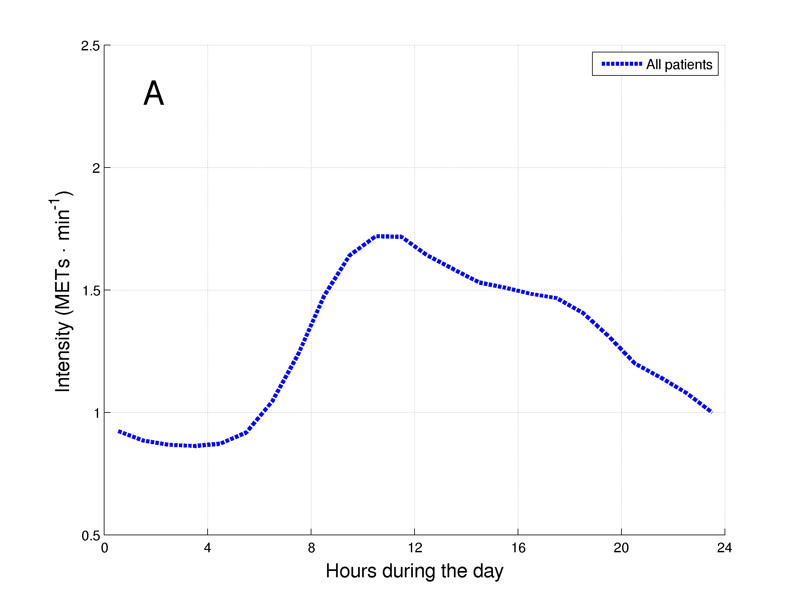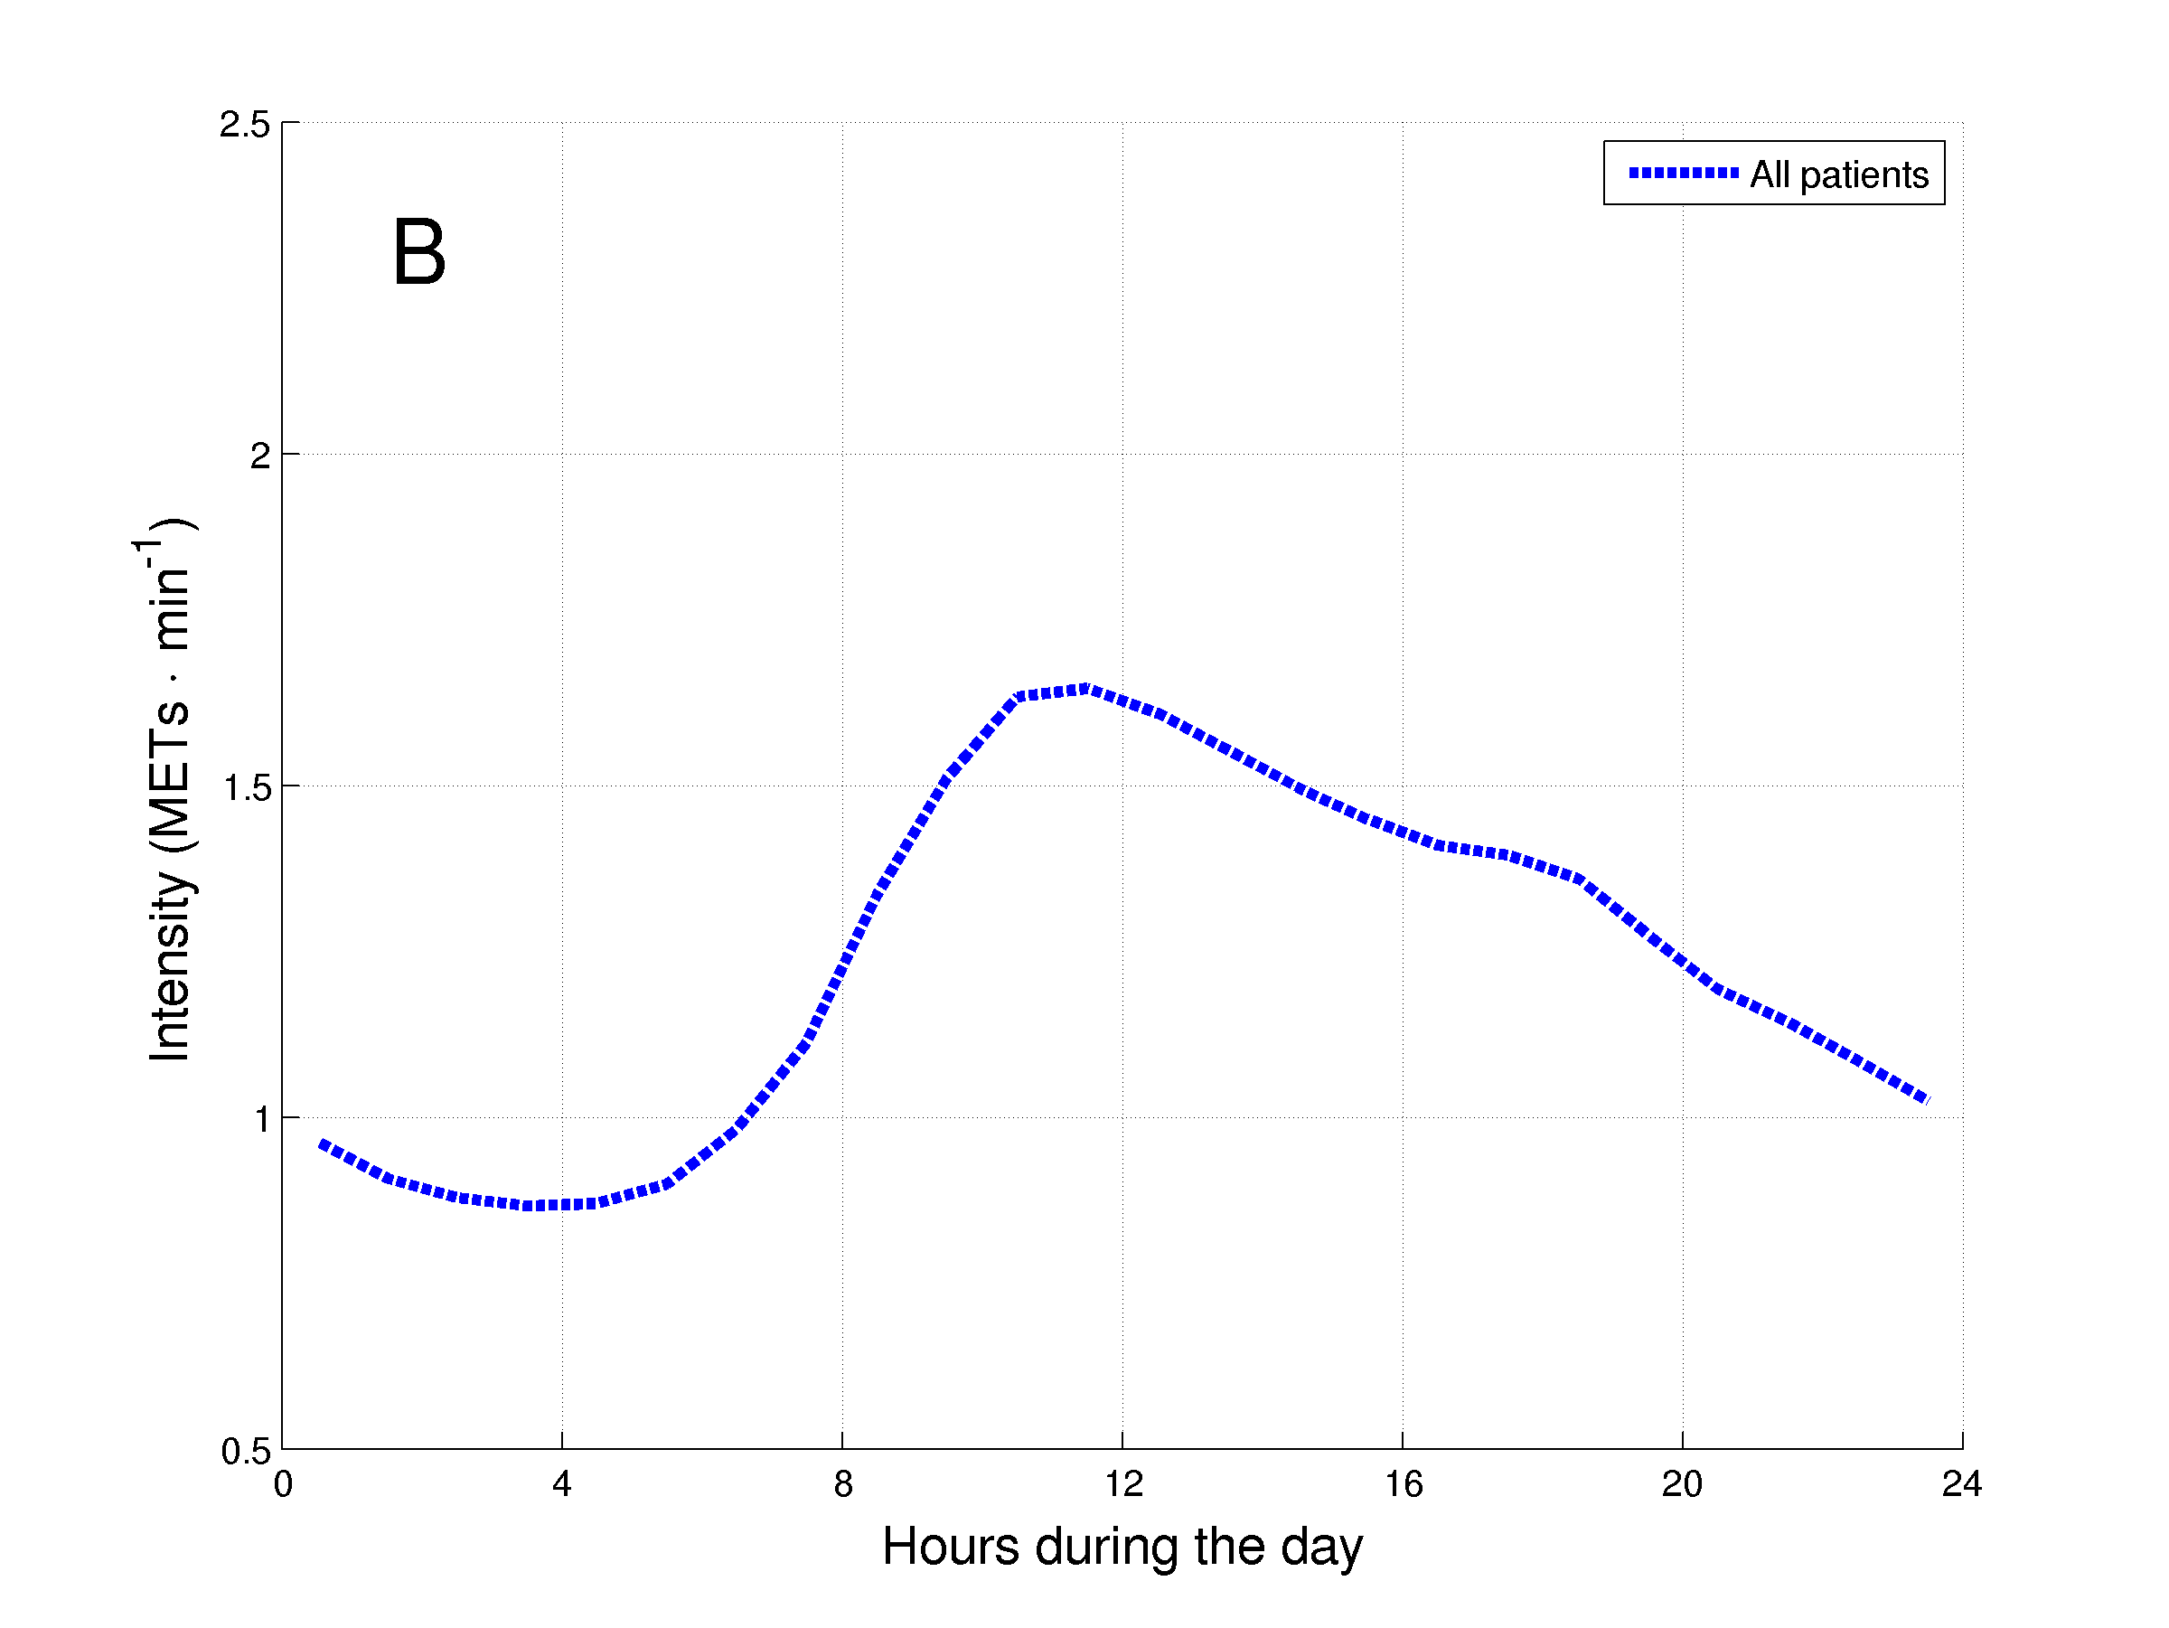
Figure 1. Daily hourly pattern of the 1001 patients with COPD during weekdays (A) and weekend days (B).
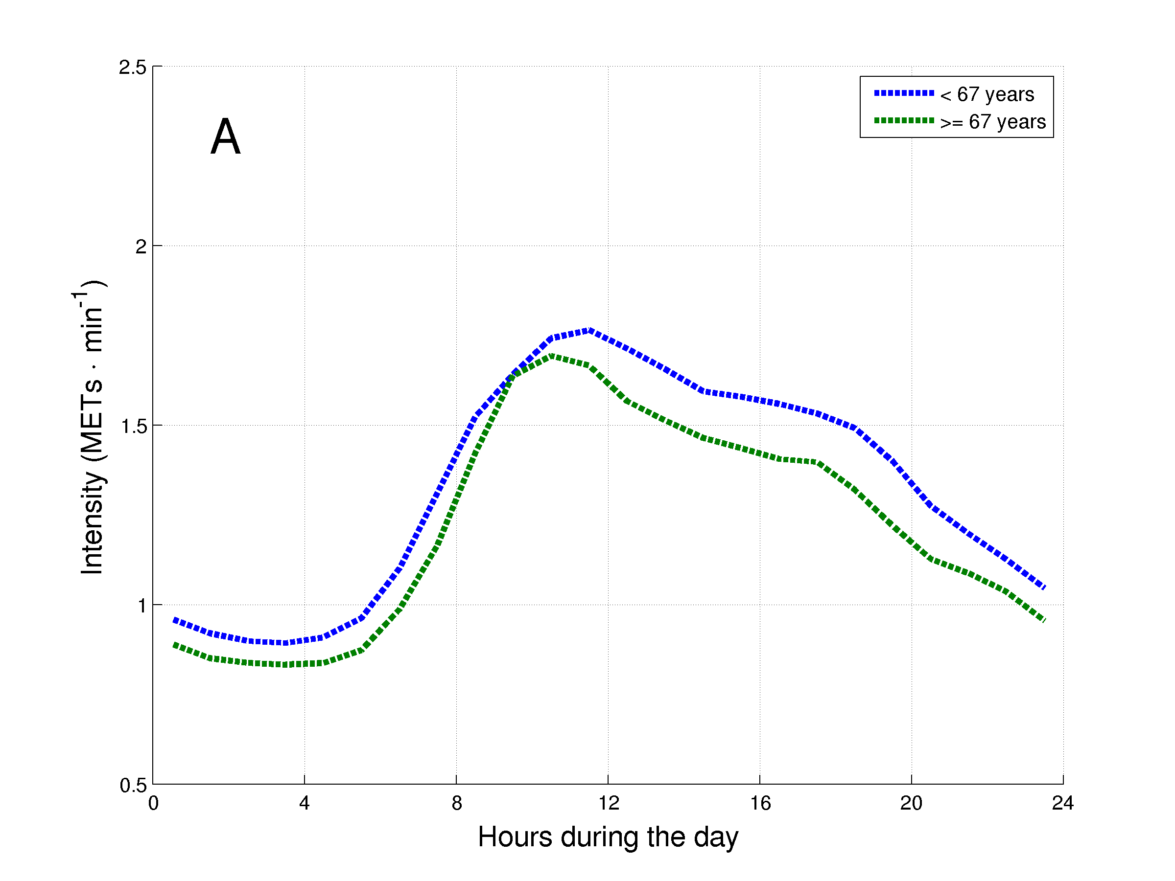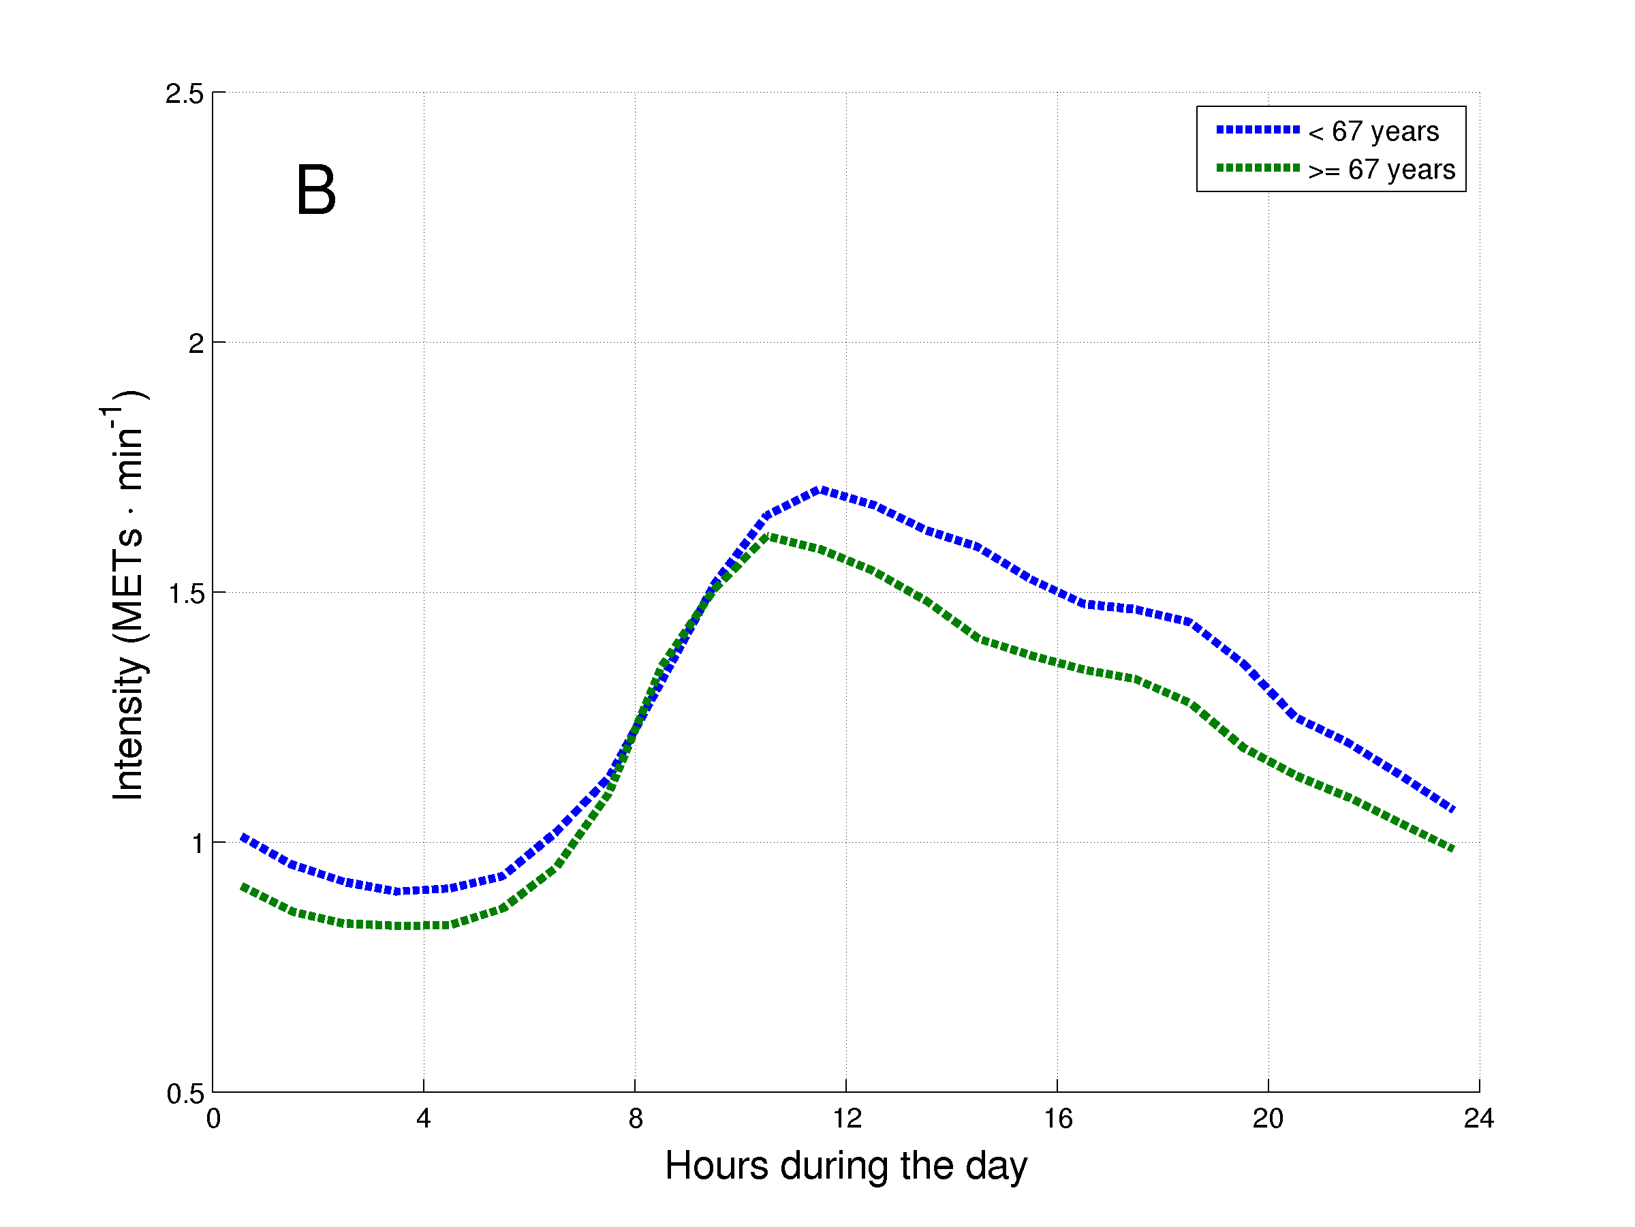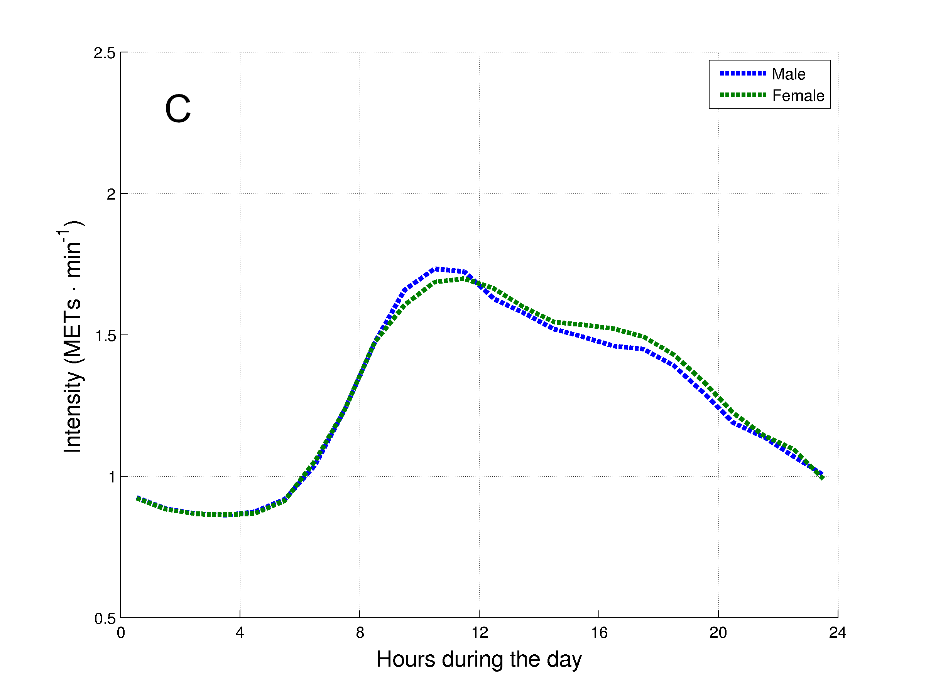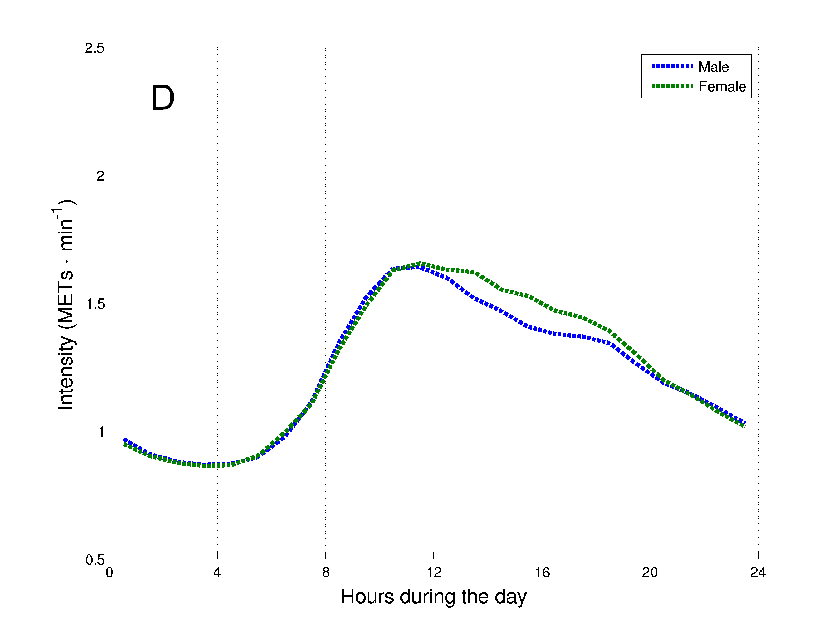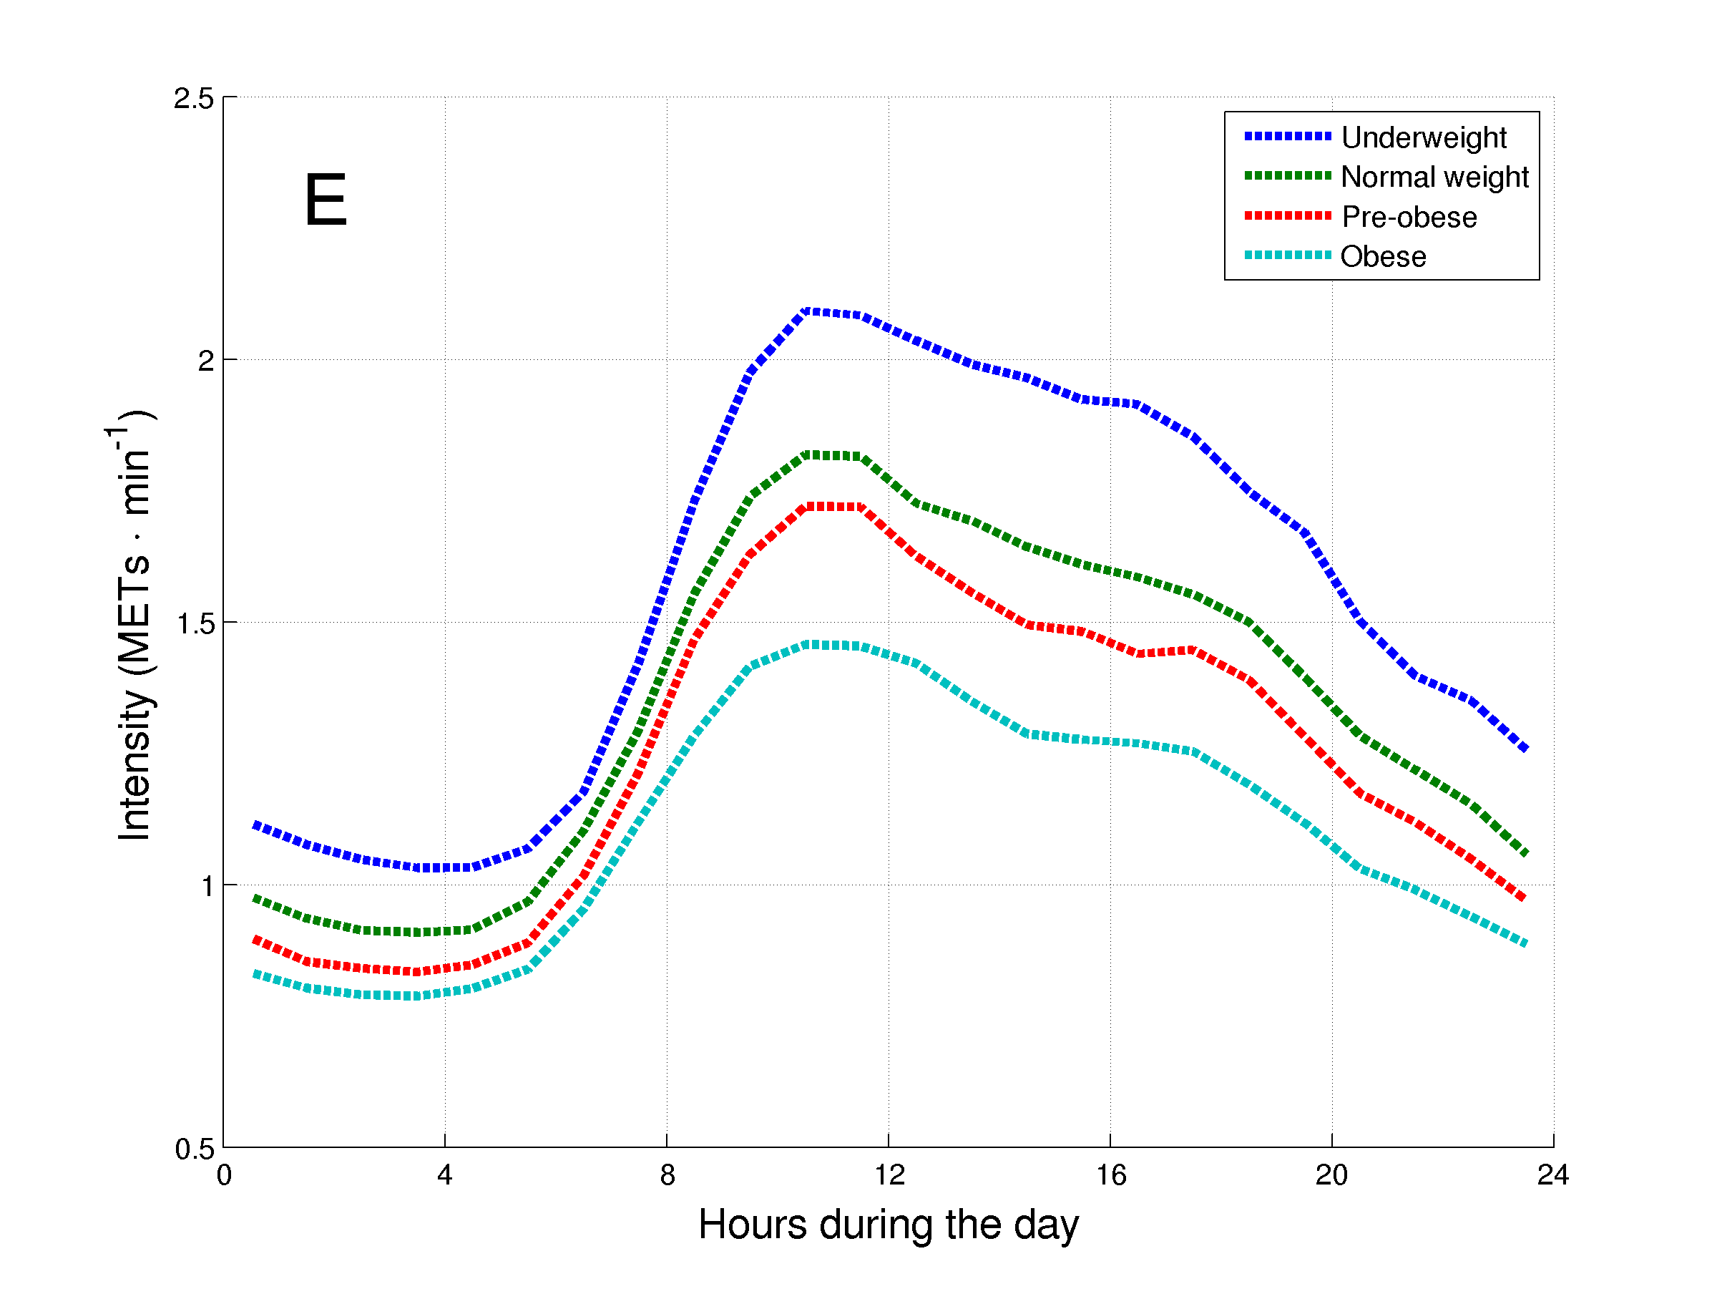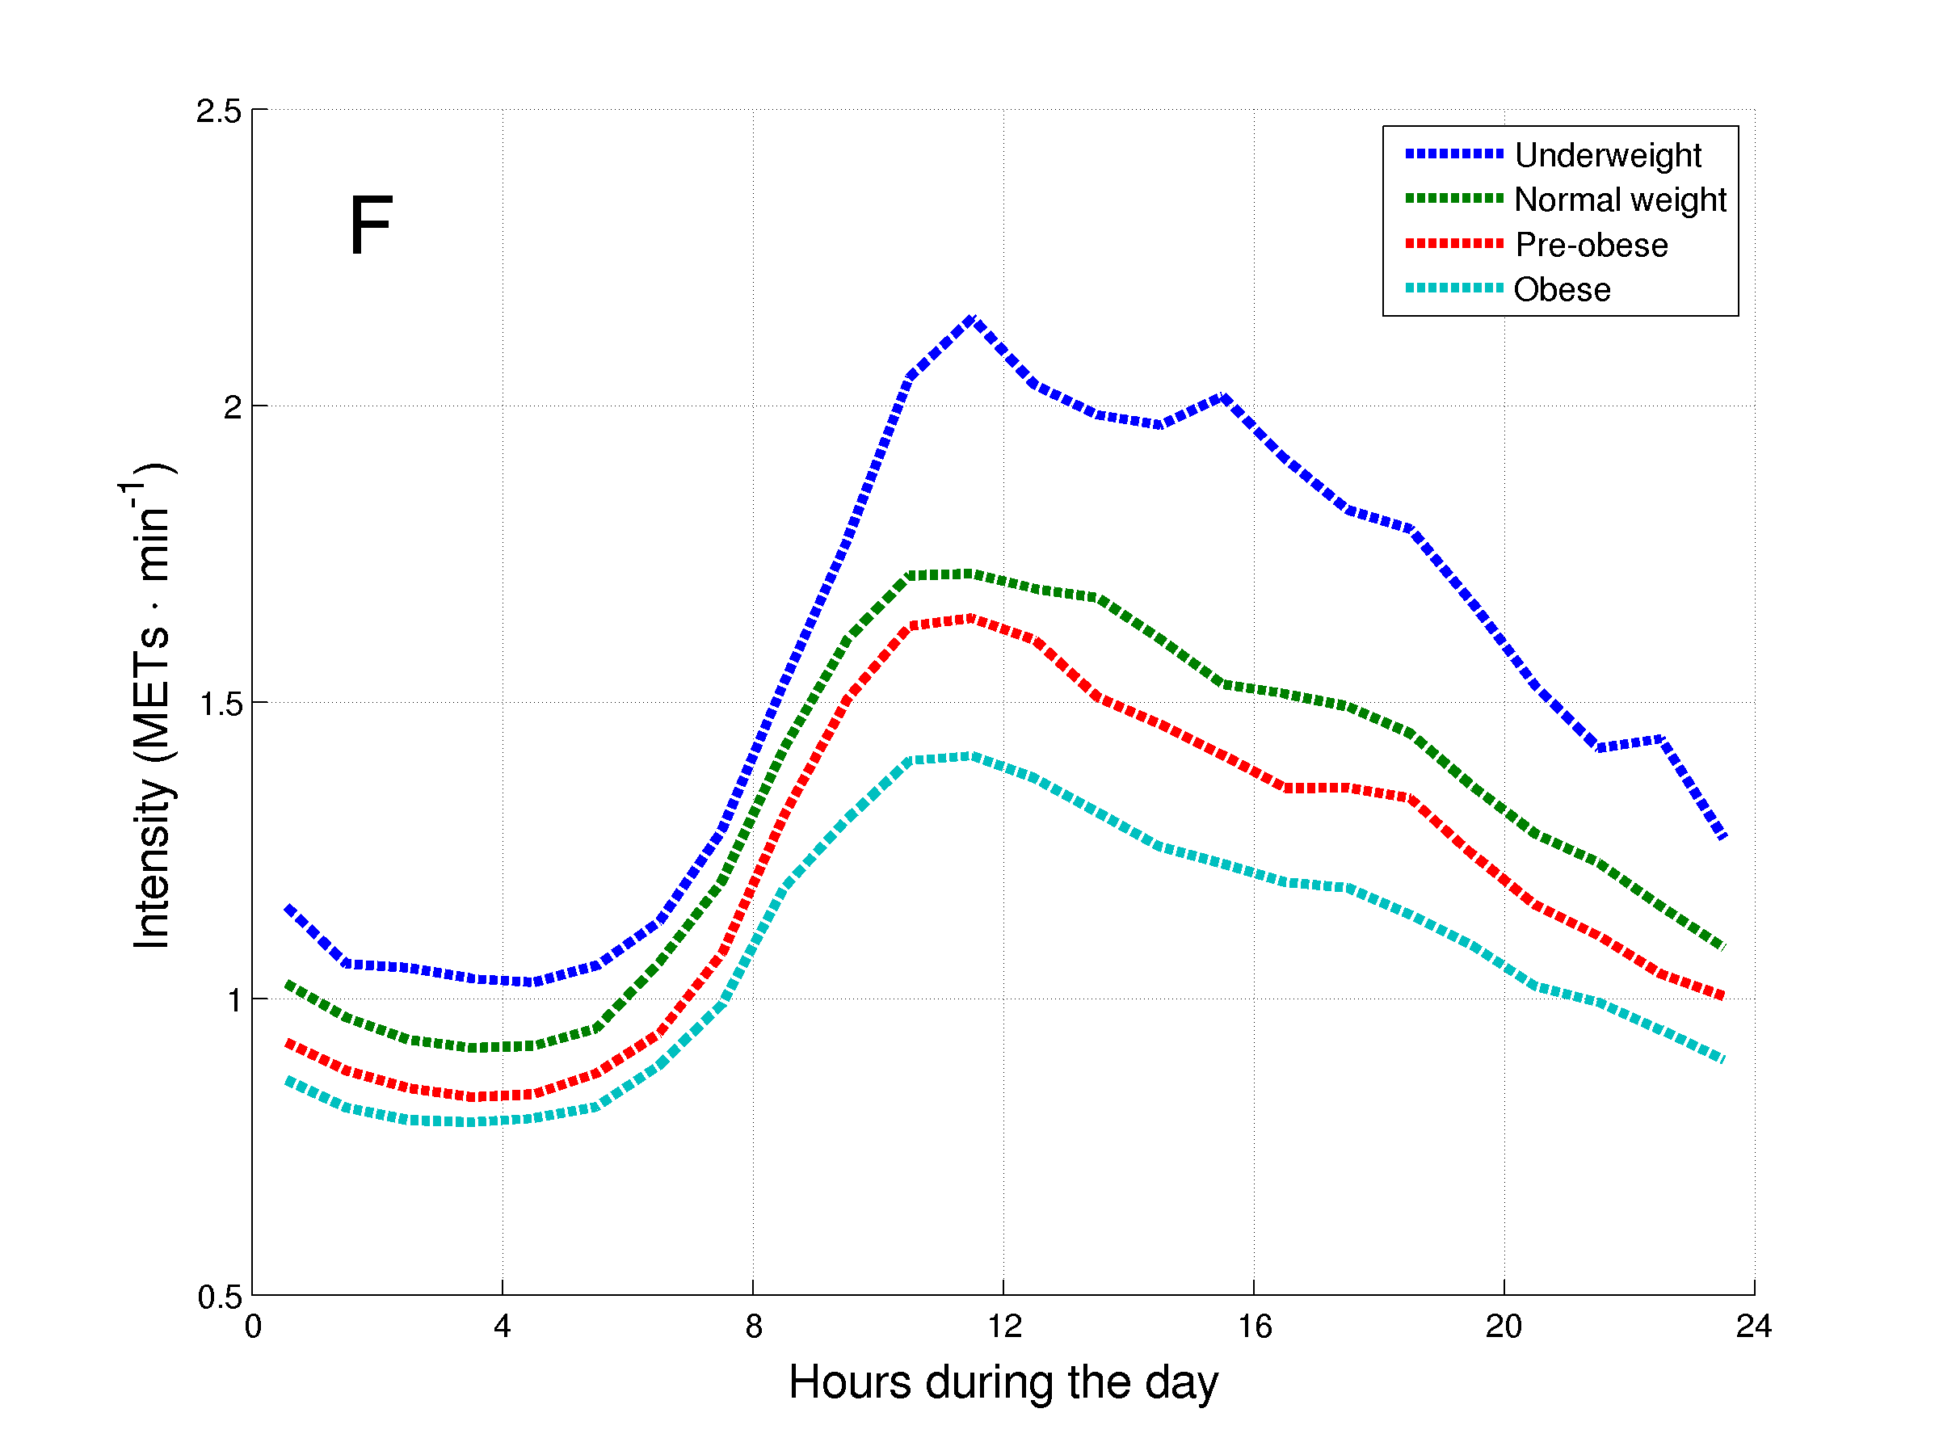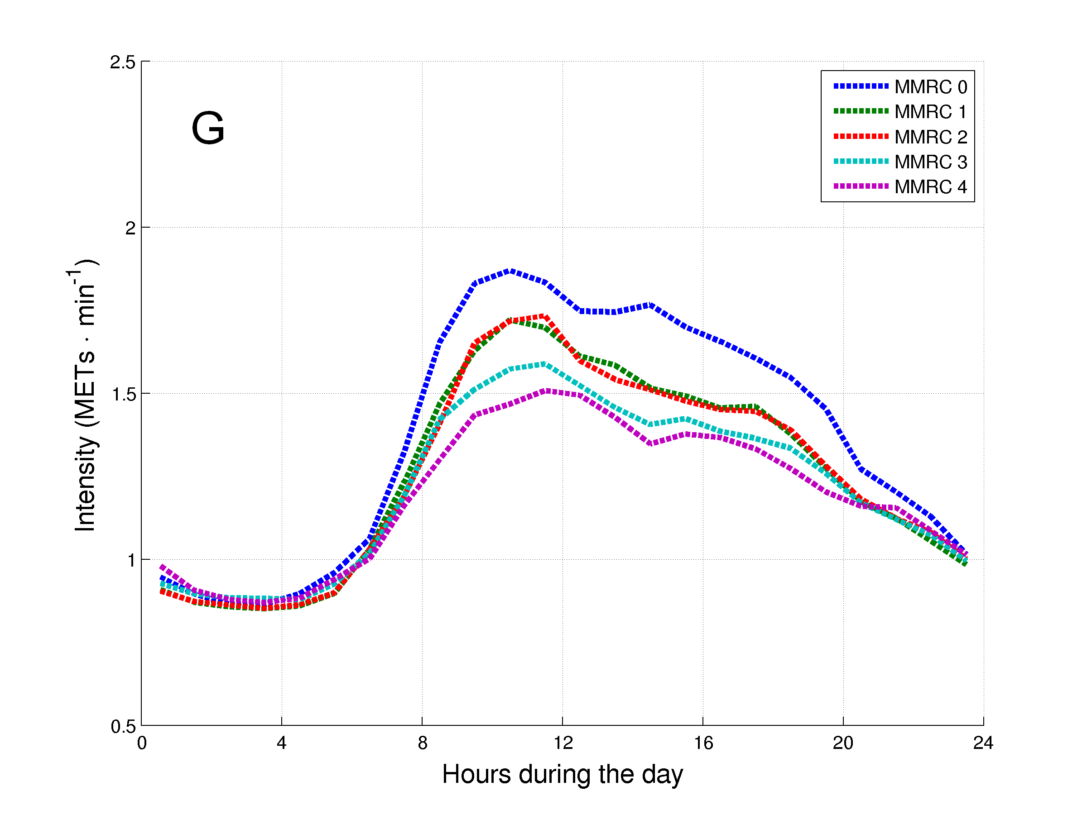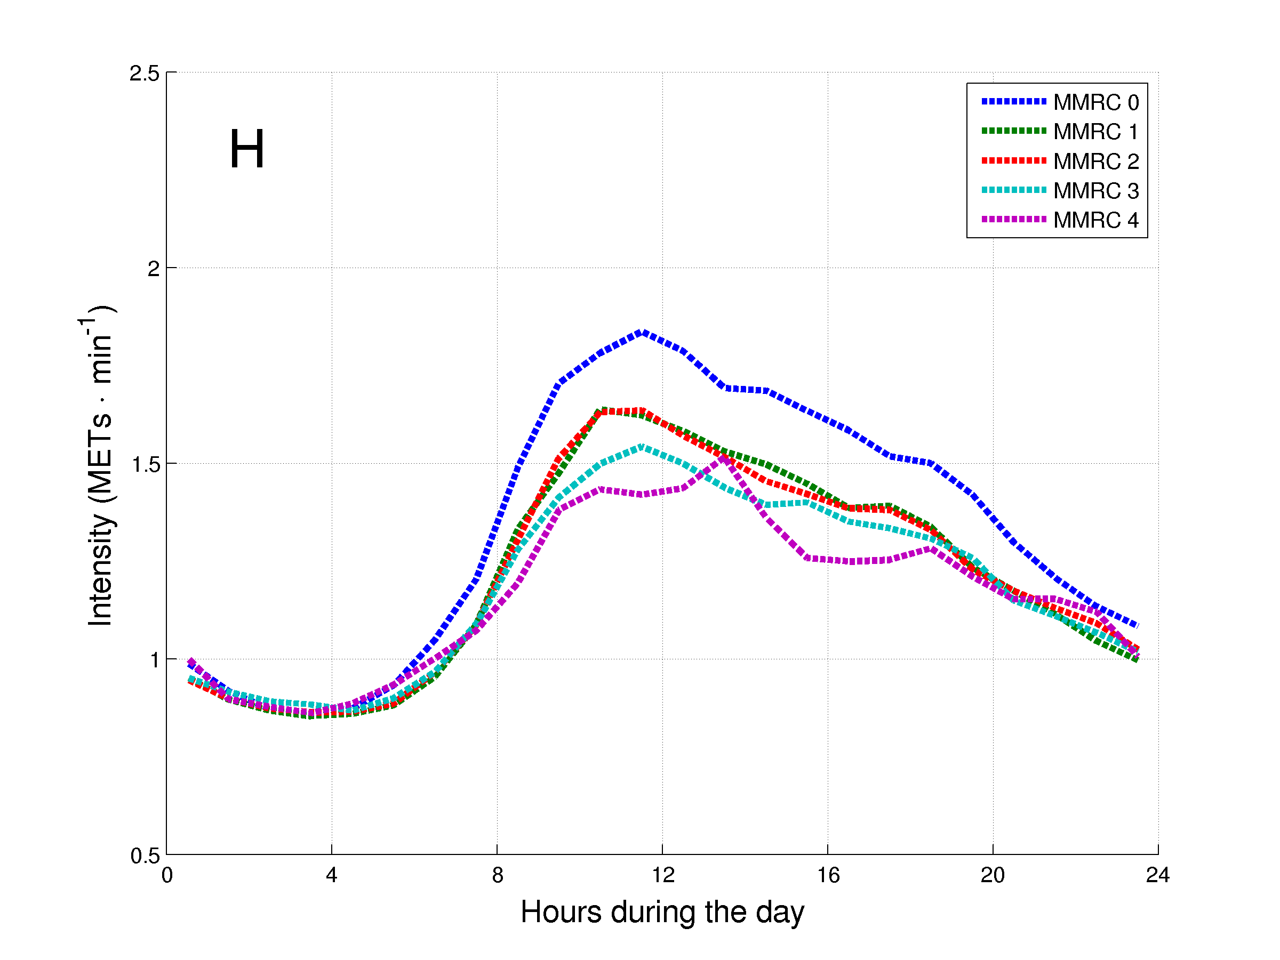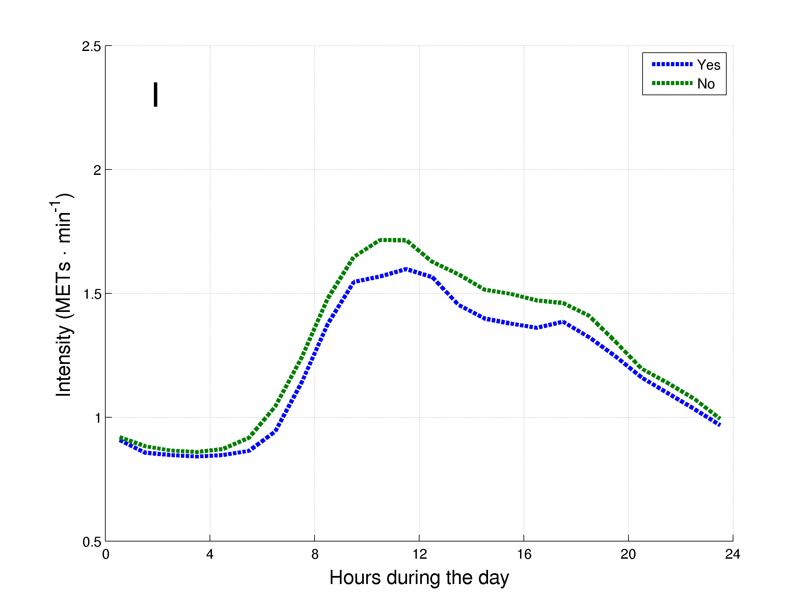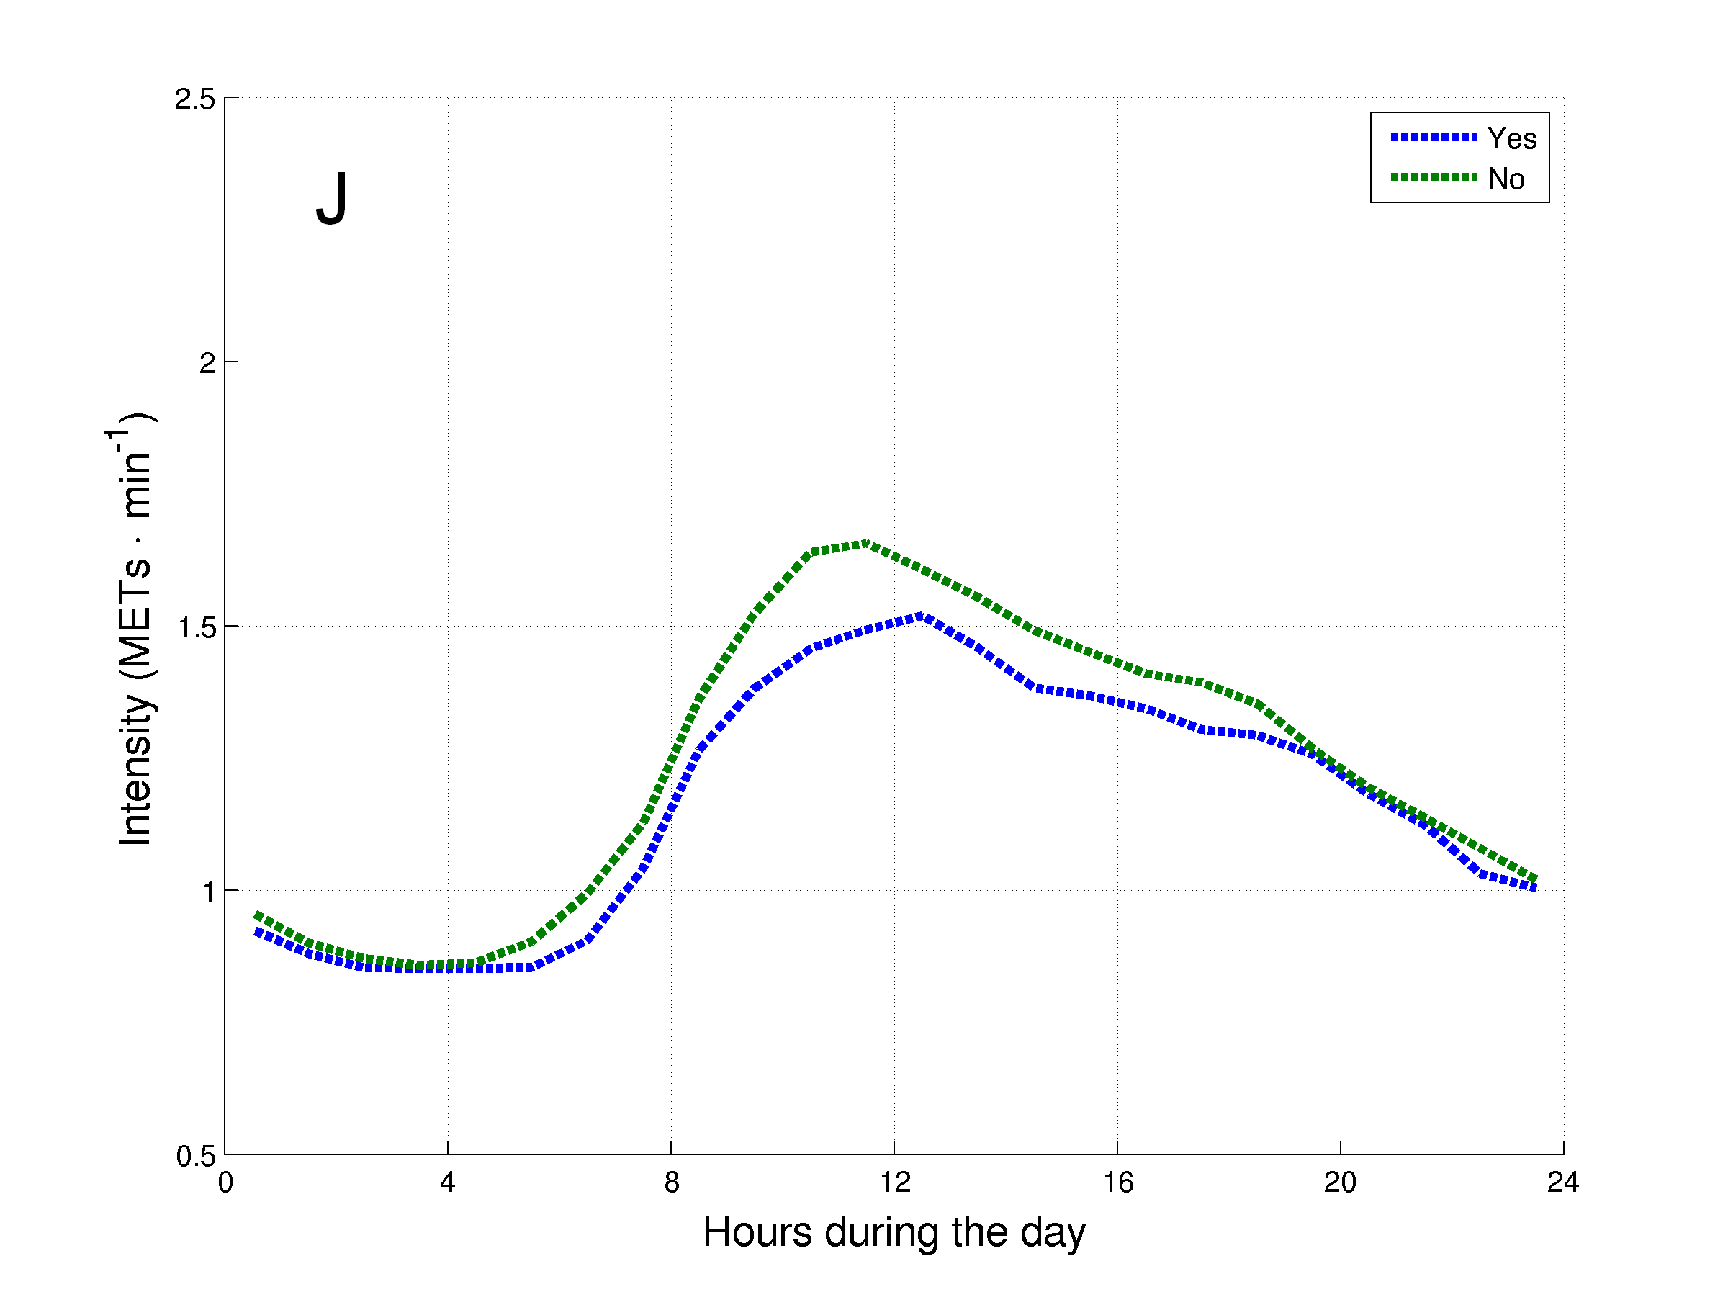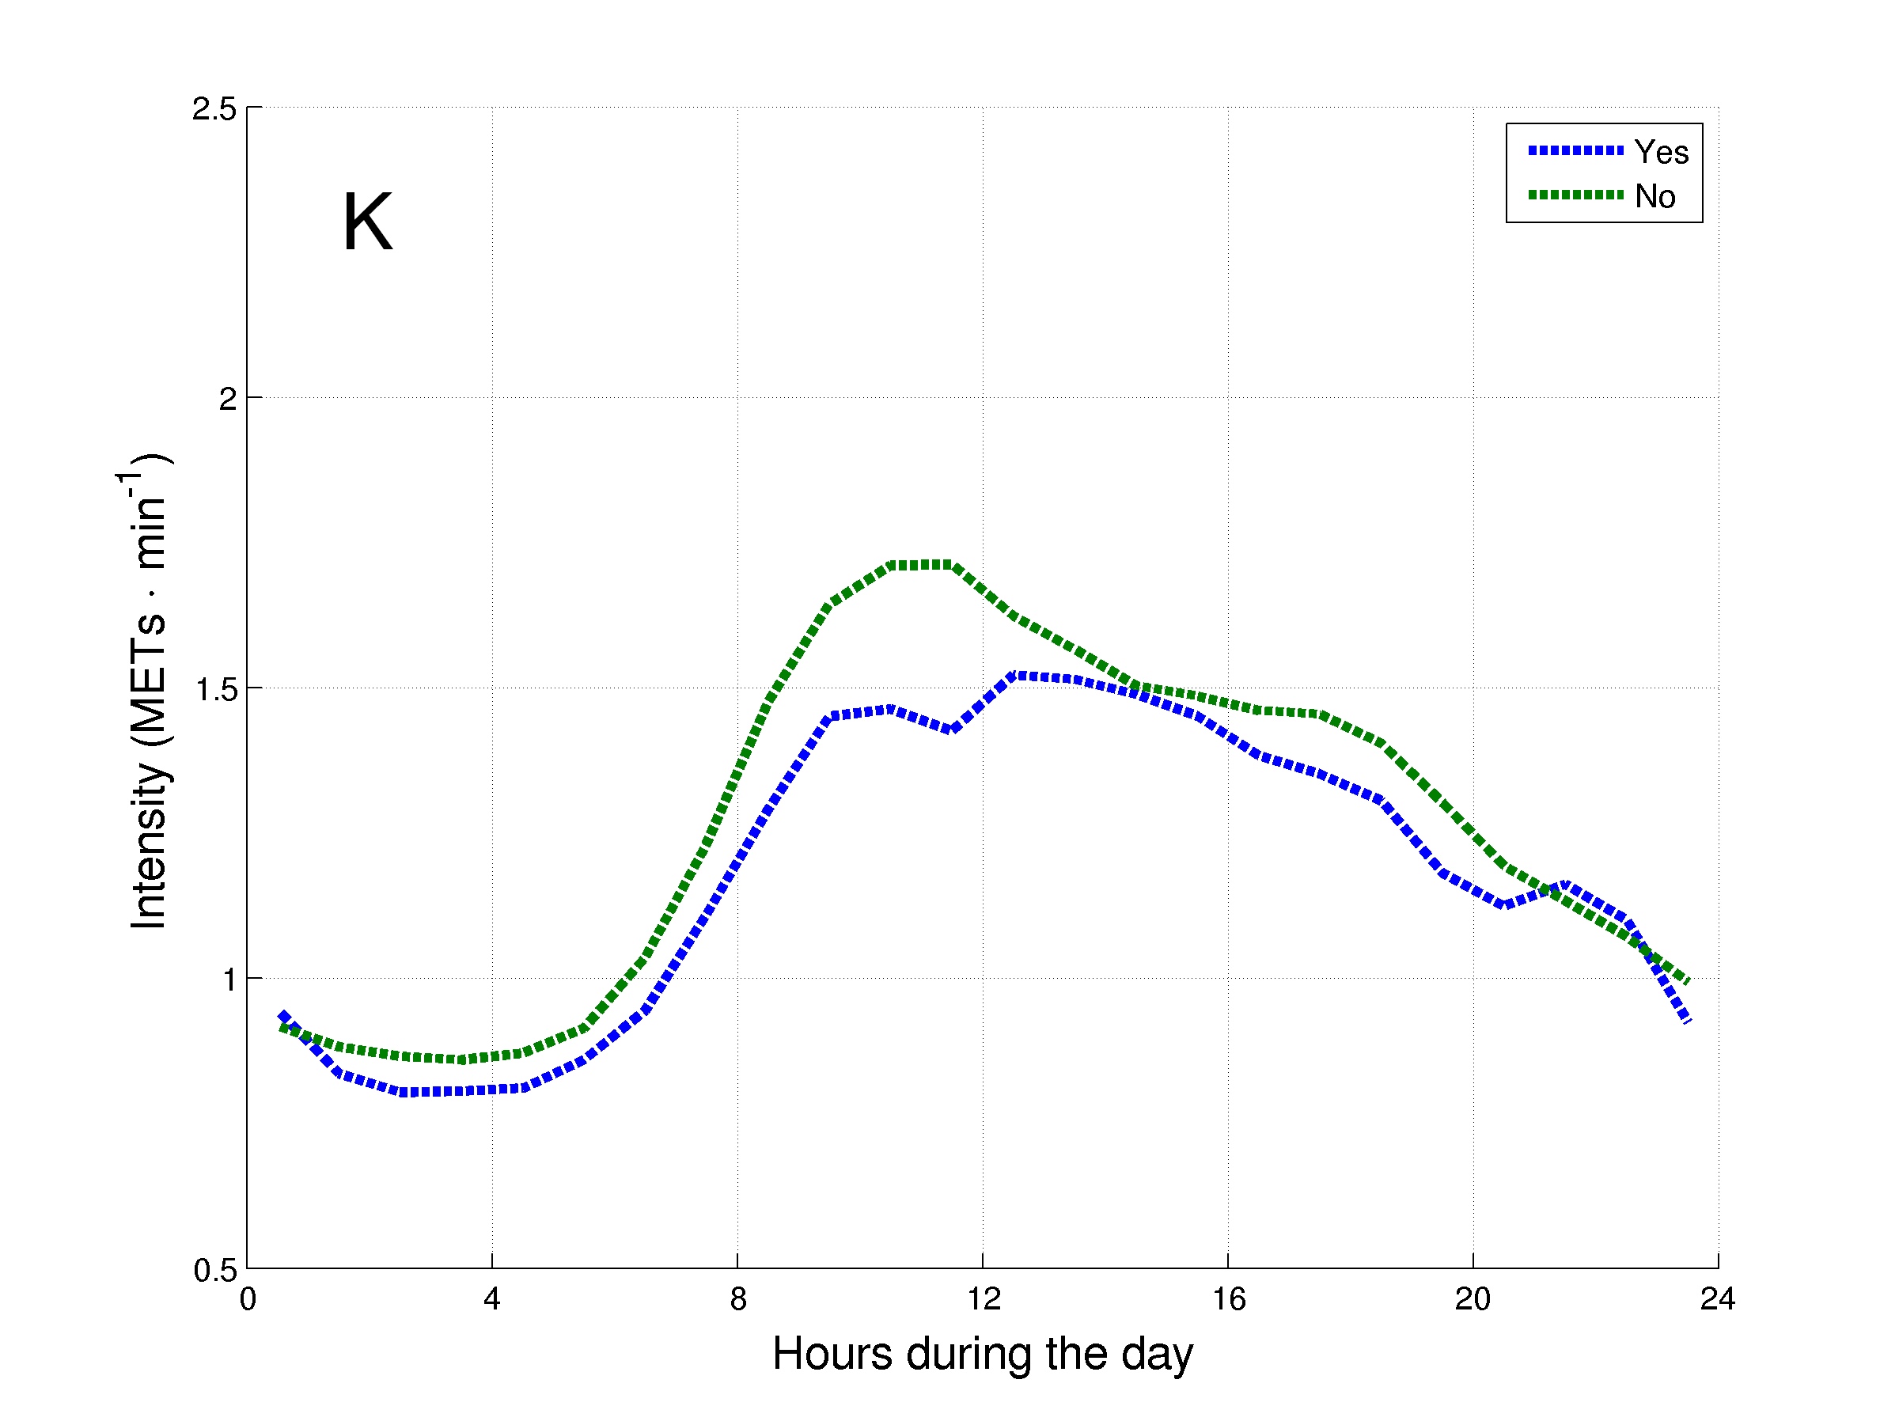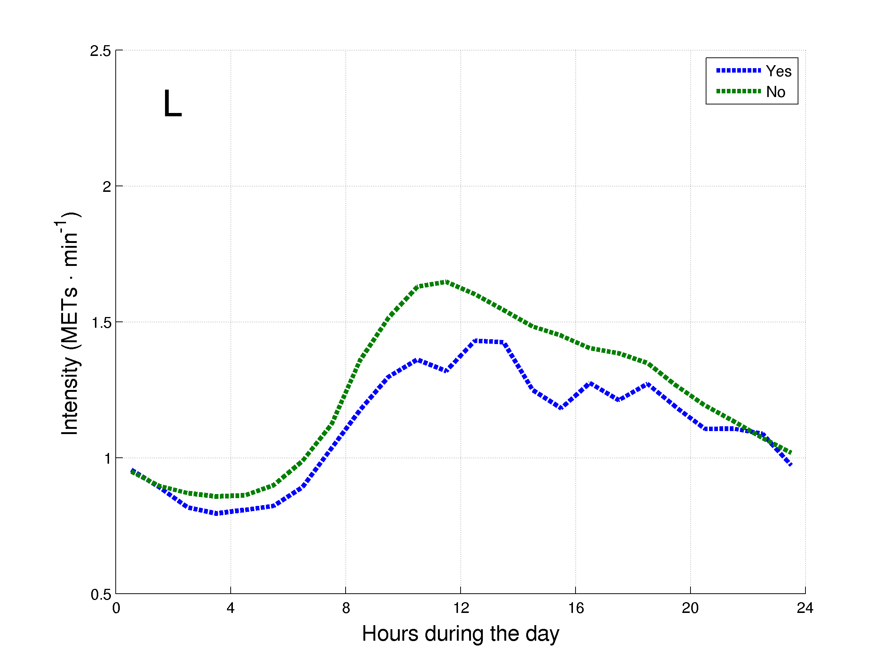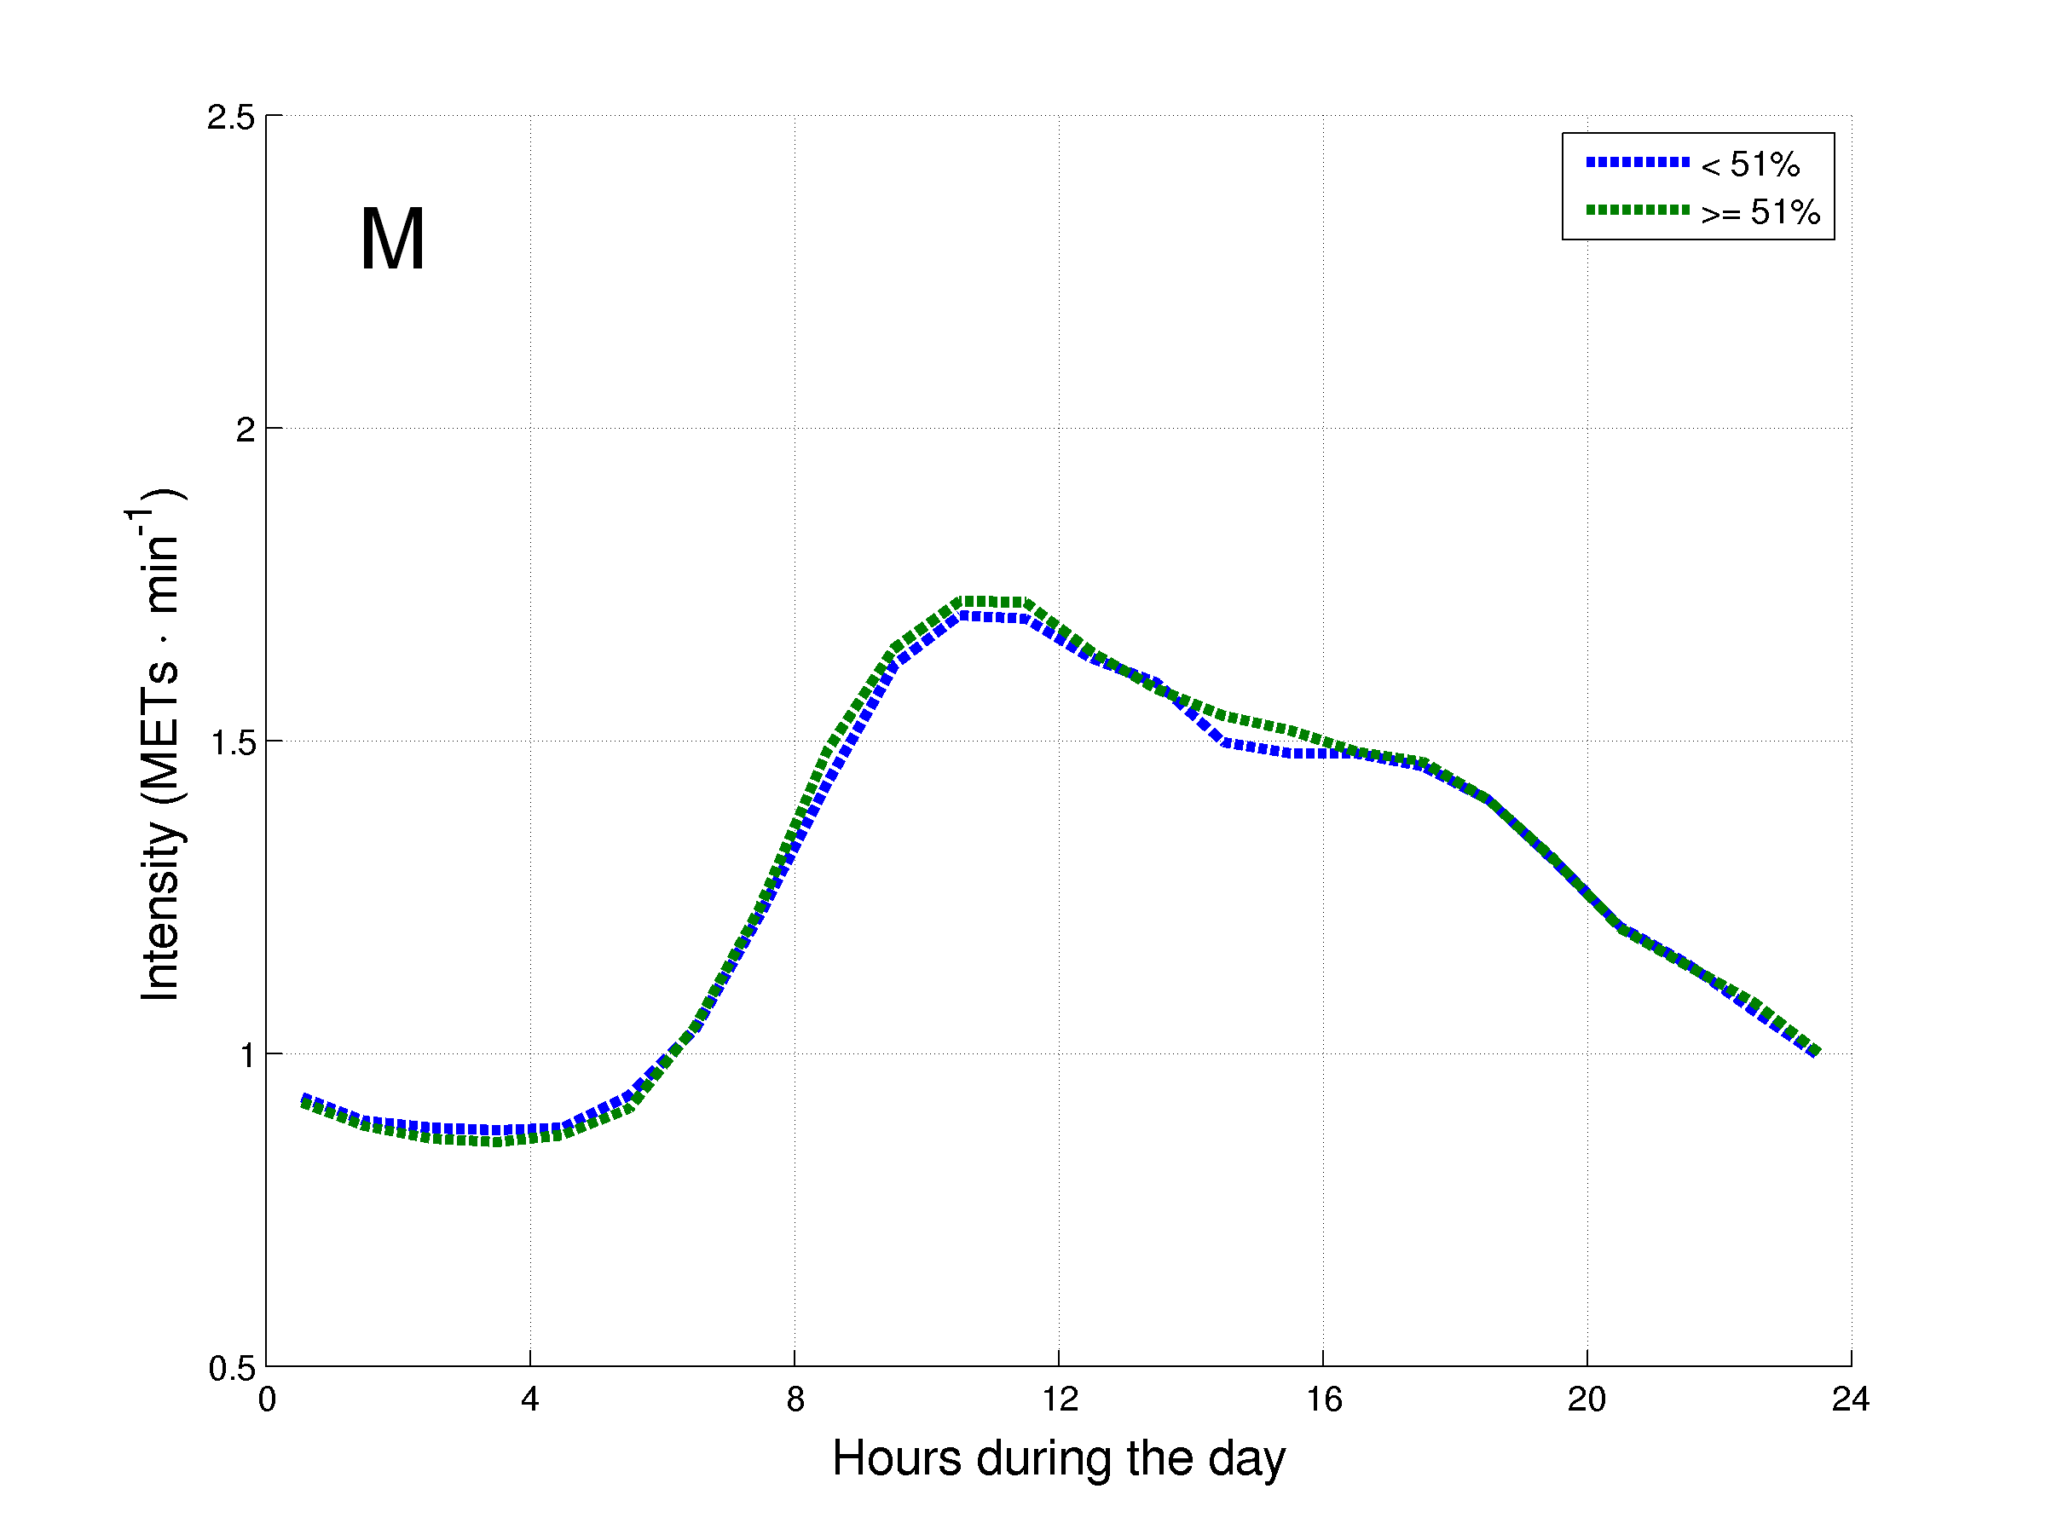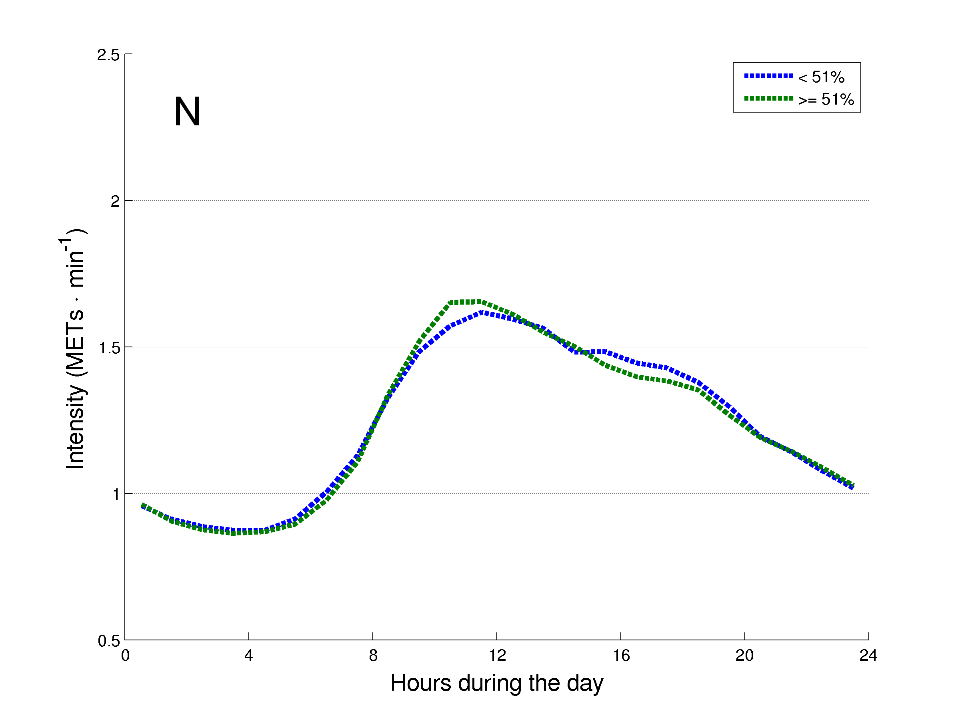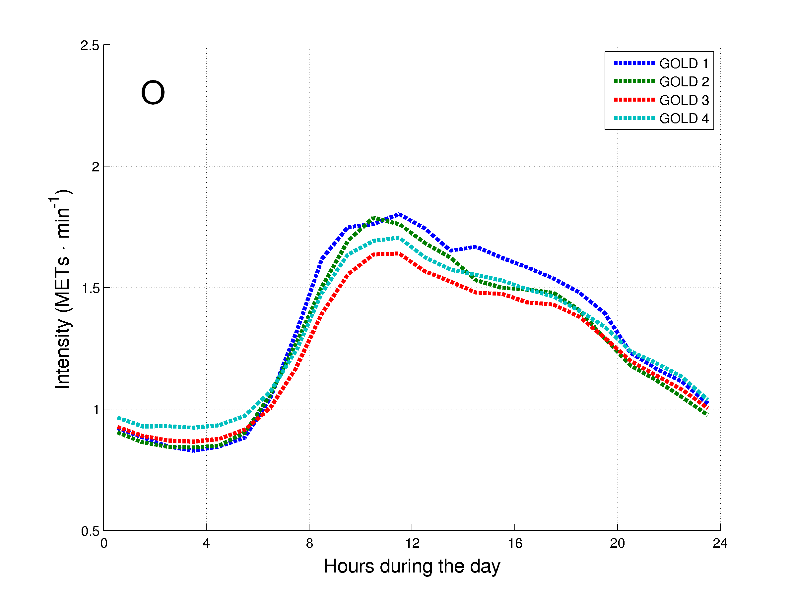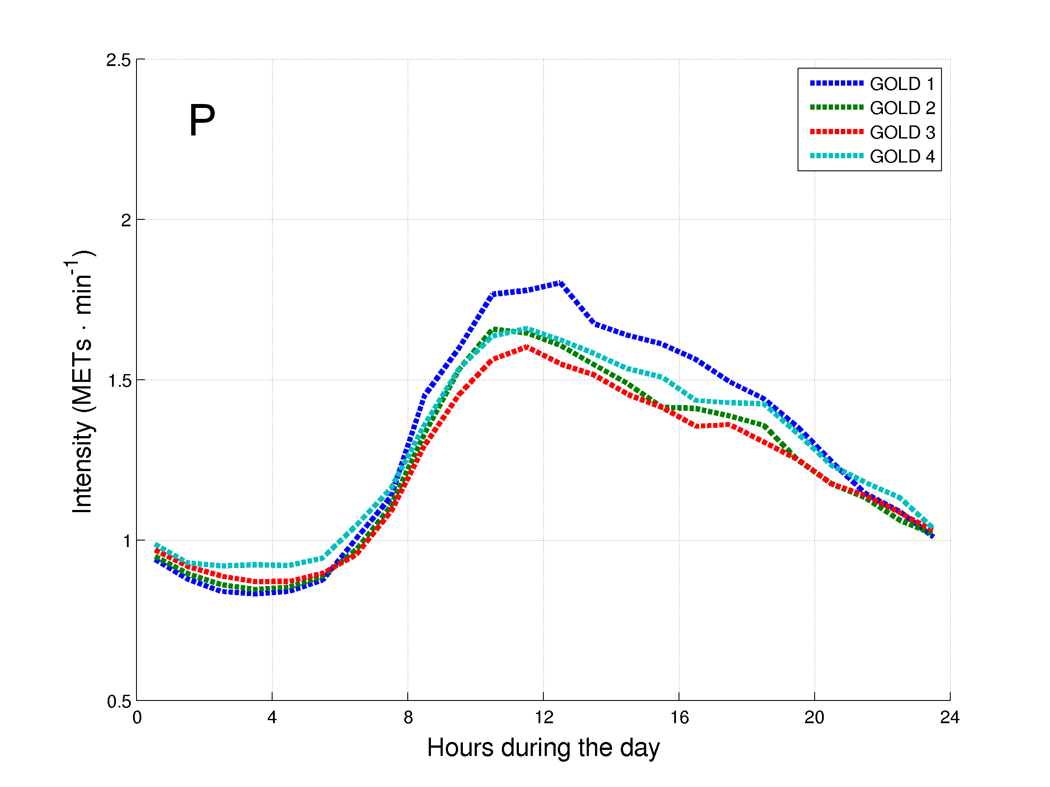
Figure 2. Daily hourly pattern of the patients with COPD after stratification for general characteristics during weekdays (A, C, E, G, I, K, M and O) and weekend days (B, D, F, H, J, L, N and P). The daily hourly pattern was stratified for: A and B – age groups; C and D – gender; E and F – body mass index (BMI) classification; G and H – modified Medical Research Council (mMRC) grades; I and J – long-term oxygen therapy (LTOT) use; K and L – walking aids use; M and N – diffusion capacity of the lung for carbon monoxide (DLCO) groups; and O and P – Global Initiative for Chronic Obstructive Lung Disease (GOLD) grades.
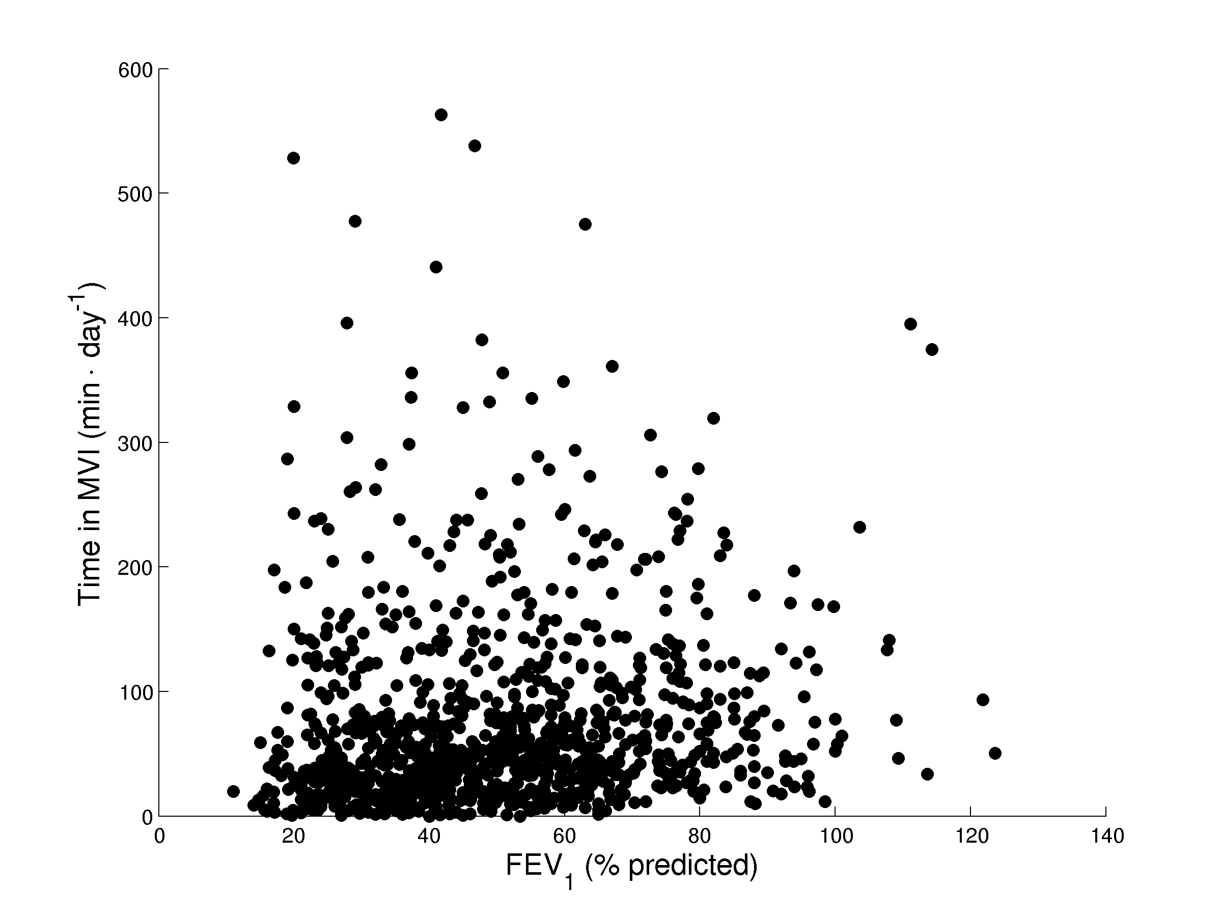
Figure 3. Spearman’s correlation between the degree of airflow limitation and the daily time in moderate-to-vigorous intensity for 1001 patients with COPD.
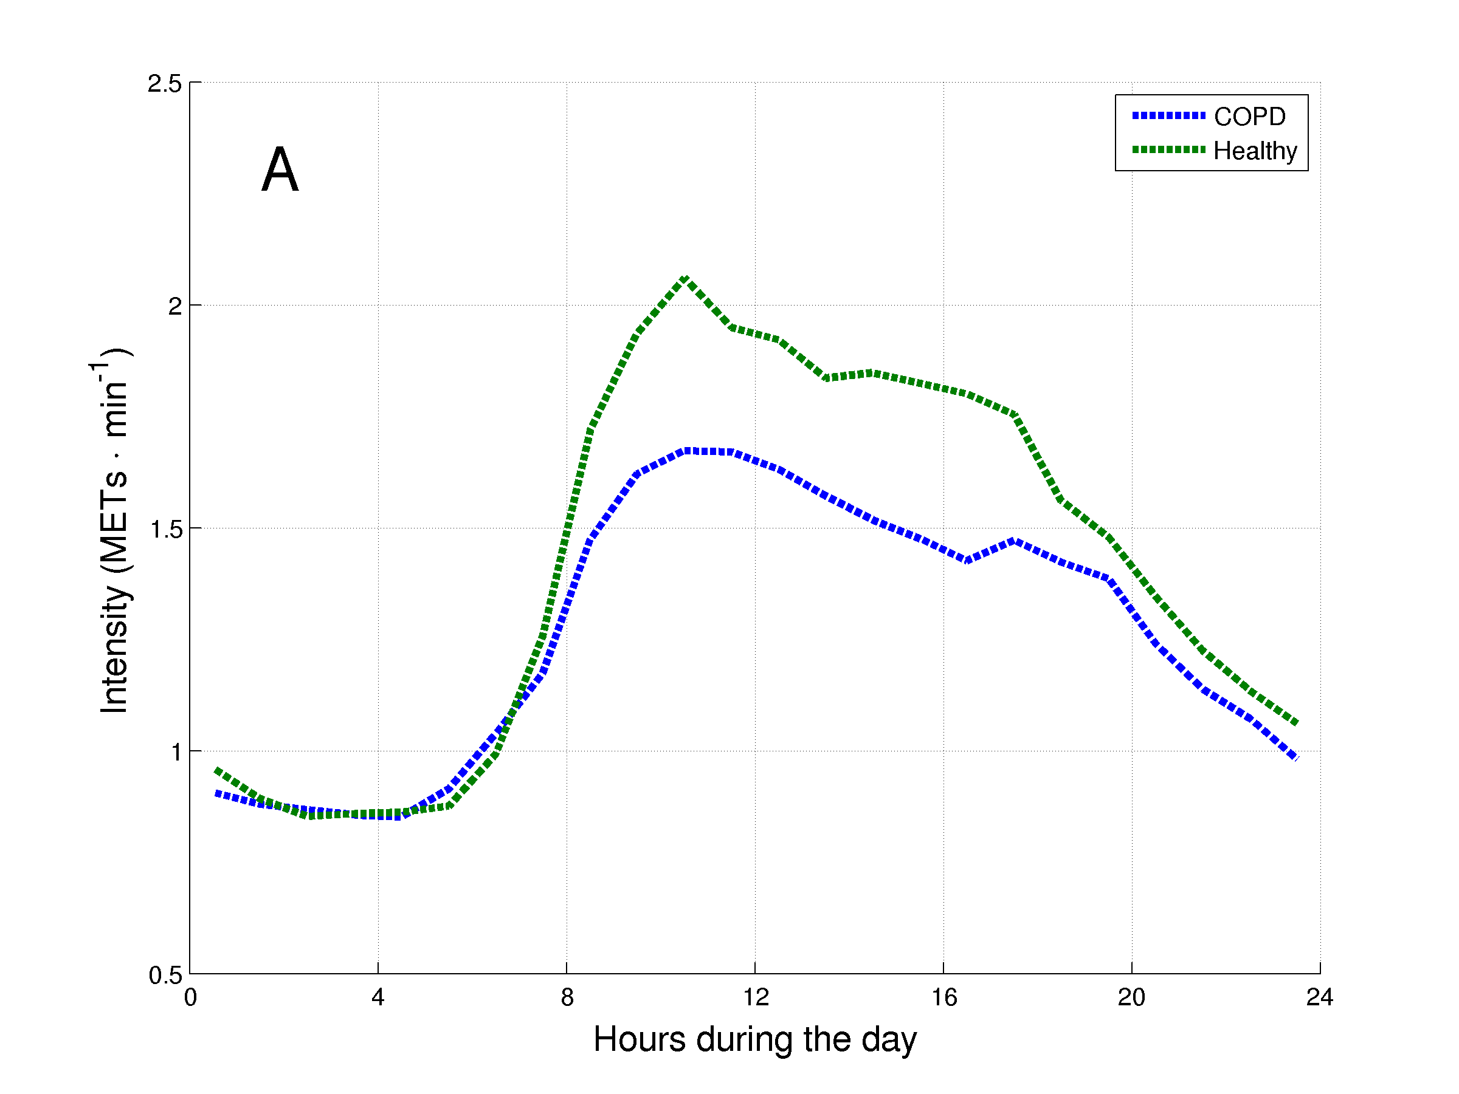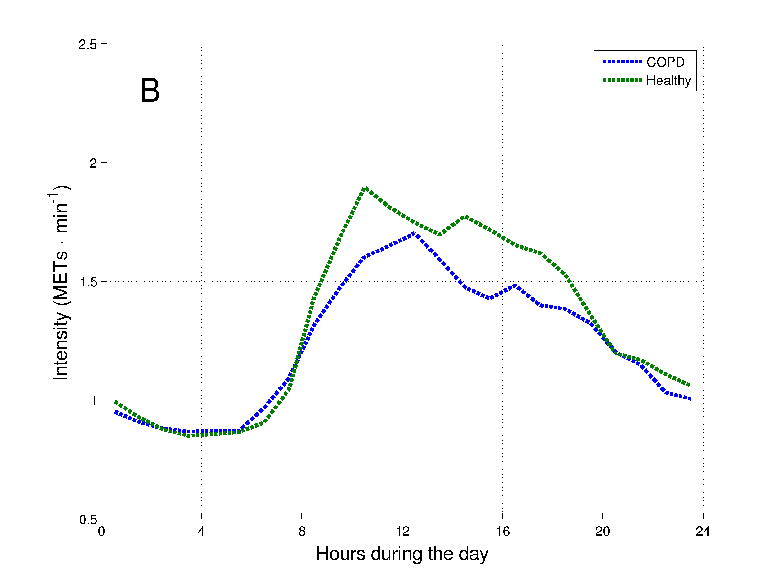
Figure 4. Daily hourly pattern of healthy subjects and matched patients with COPD during weekdays (A) and weekend days (B).
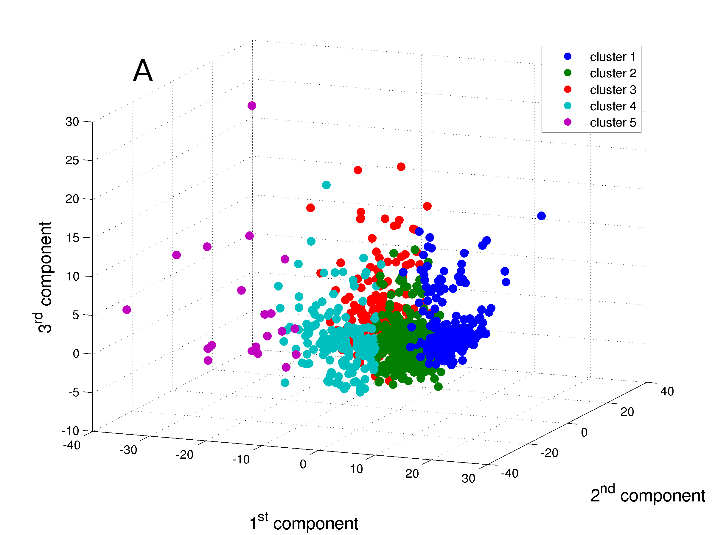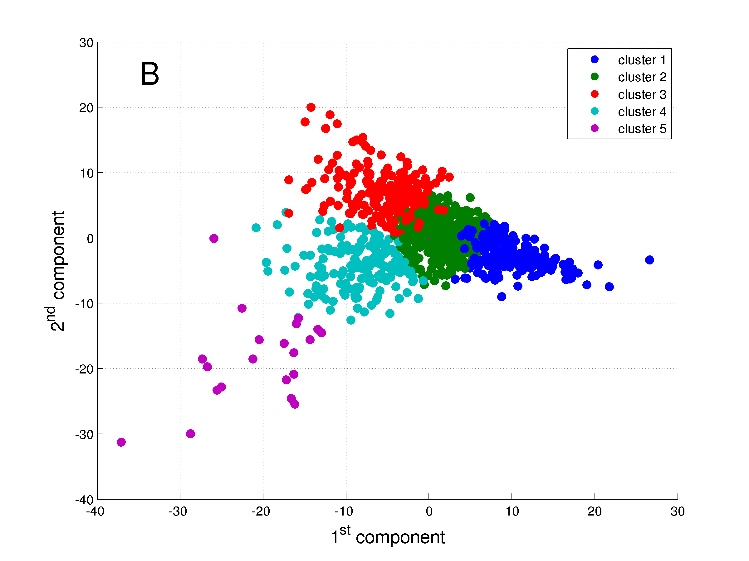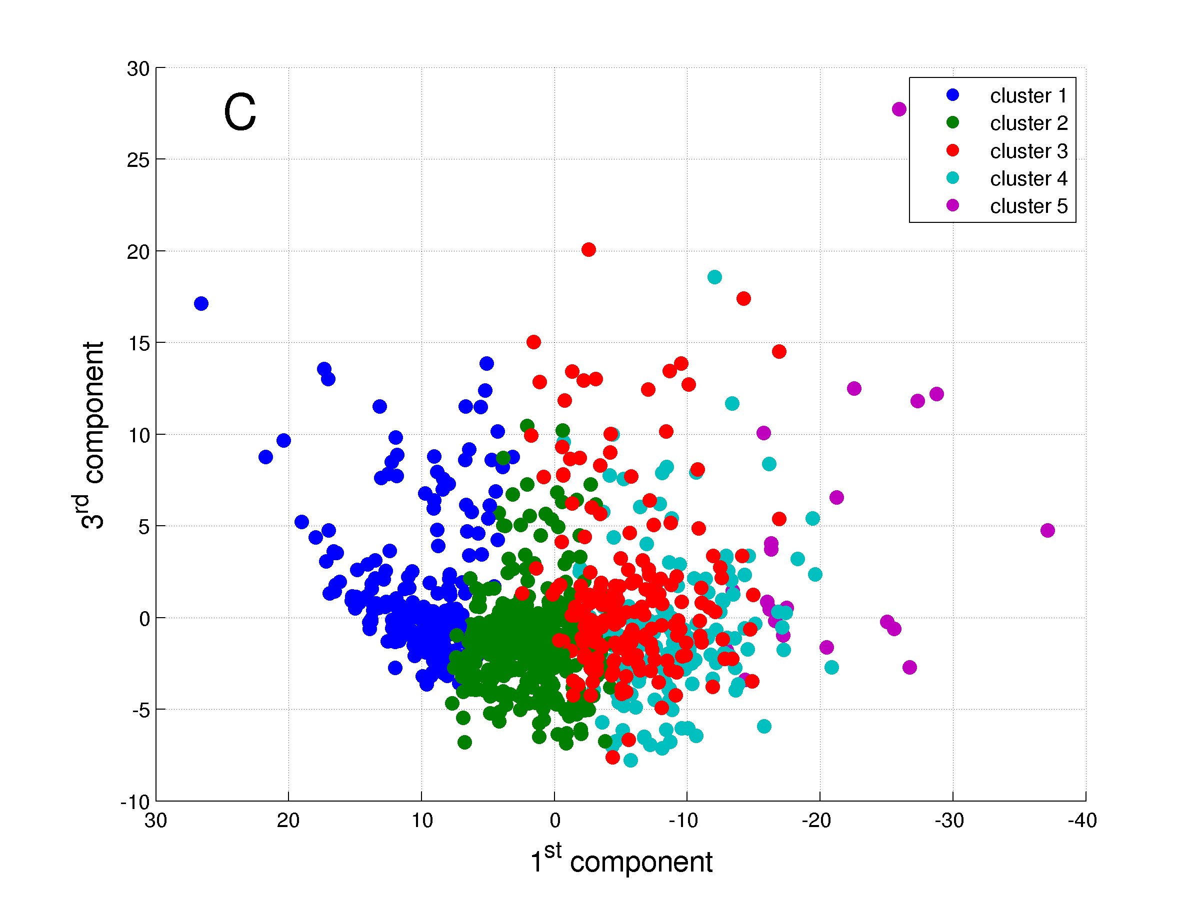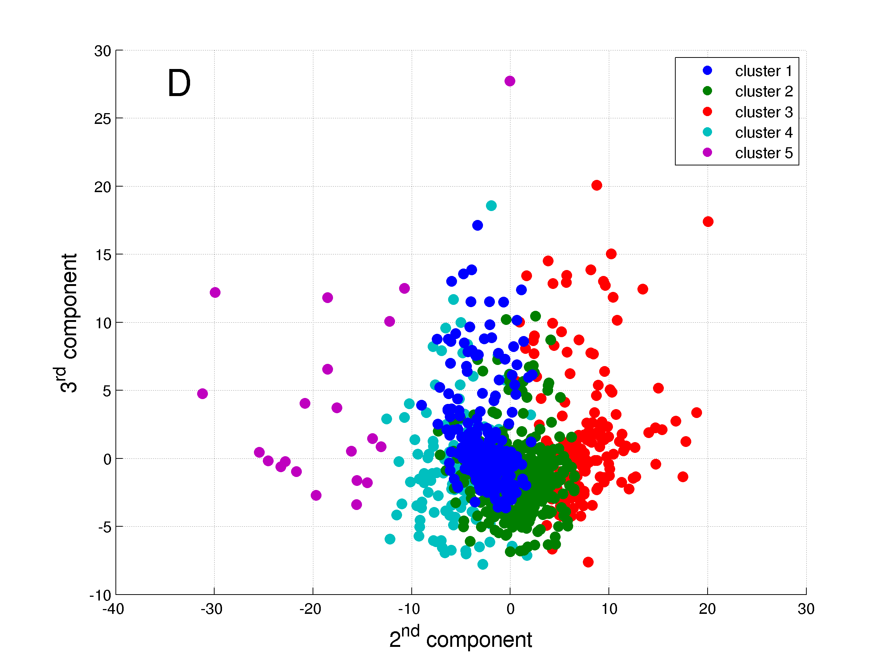
Figure 5. The five clusters identified. A: Graph in 3 dimensions presenting the three components from the PCA; B: Graph in 2 dimensions presenting the 1st and 2nd components; C: Graph in 2 dimensions presenting the 1st and 3rd components; and D: Graph in 2 dimensions presenting the 2nd and 3rd components. Details about the relationship between components and clusters can be found in the online supplement.
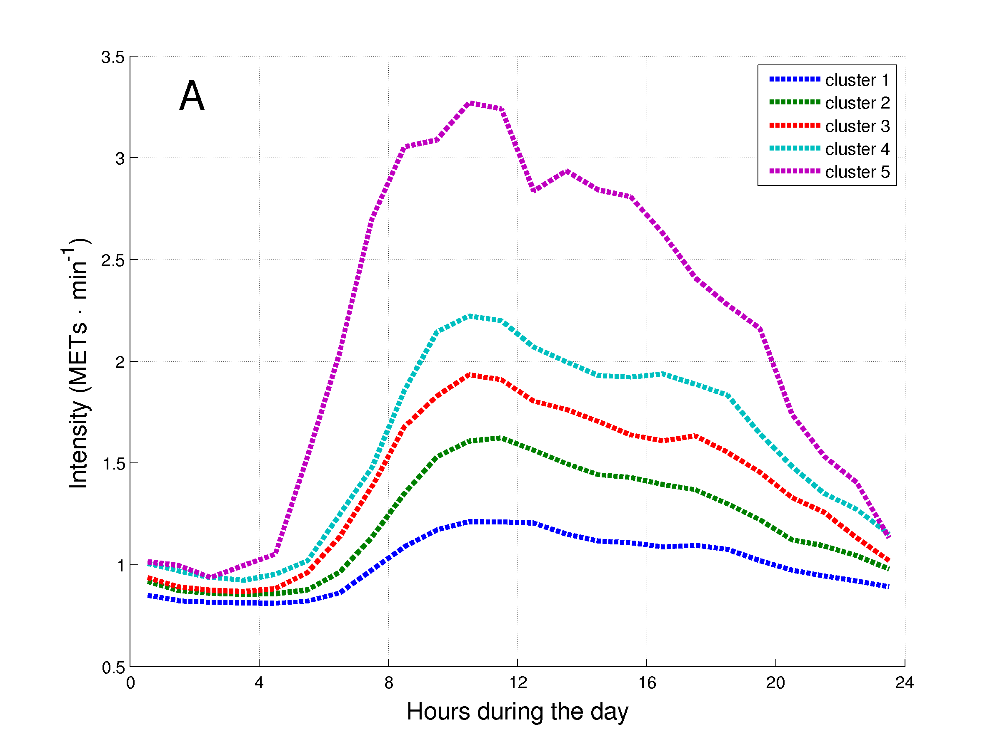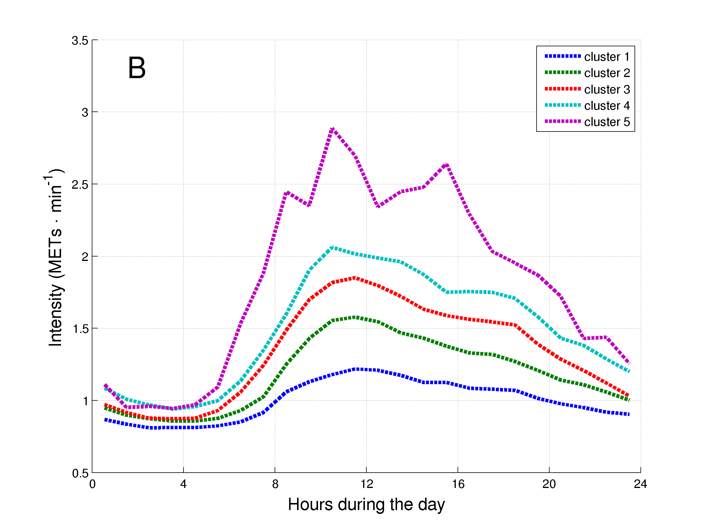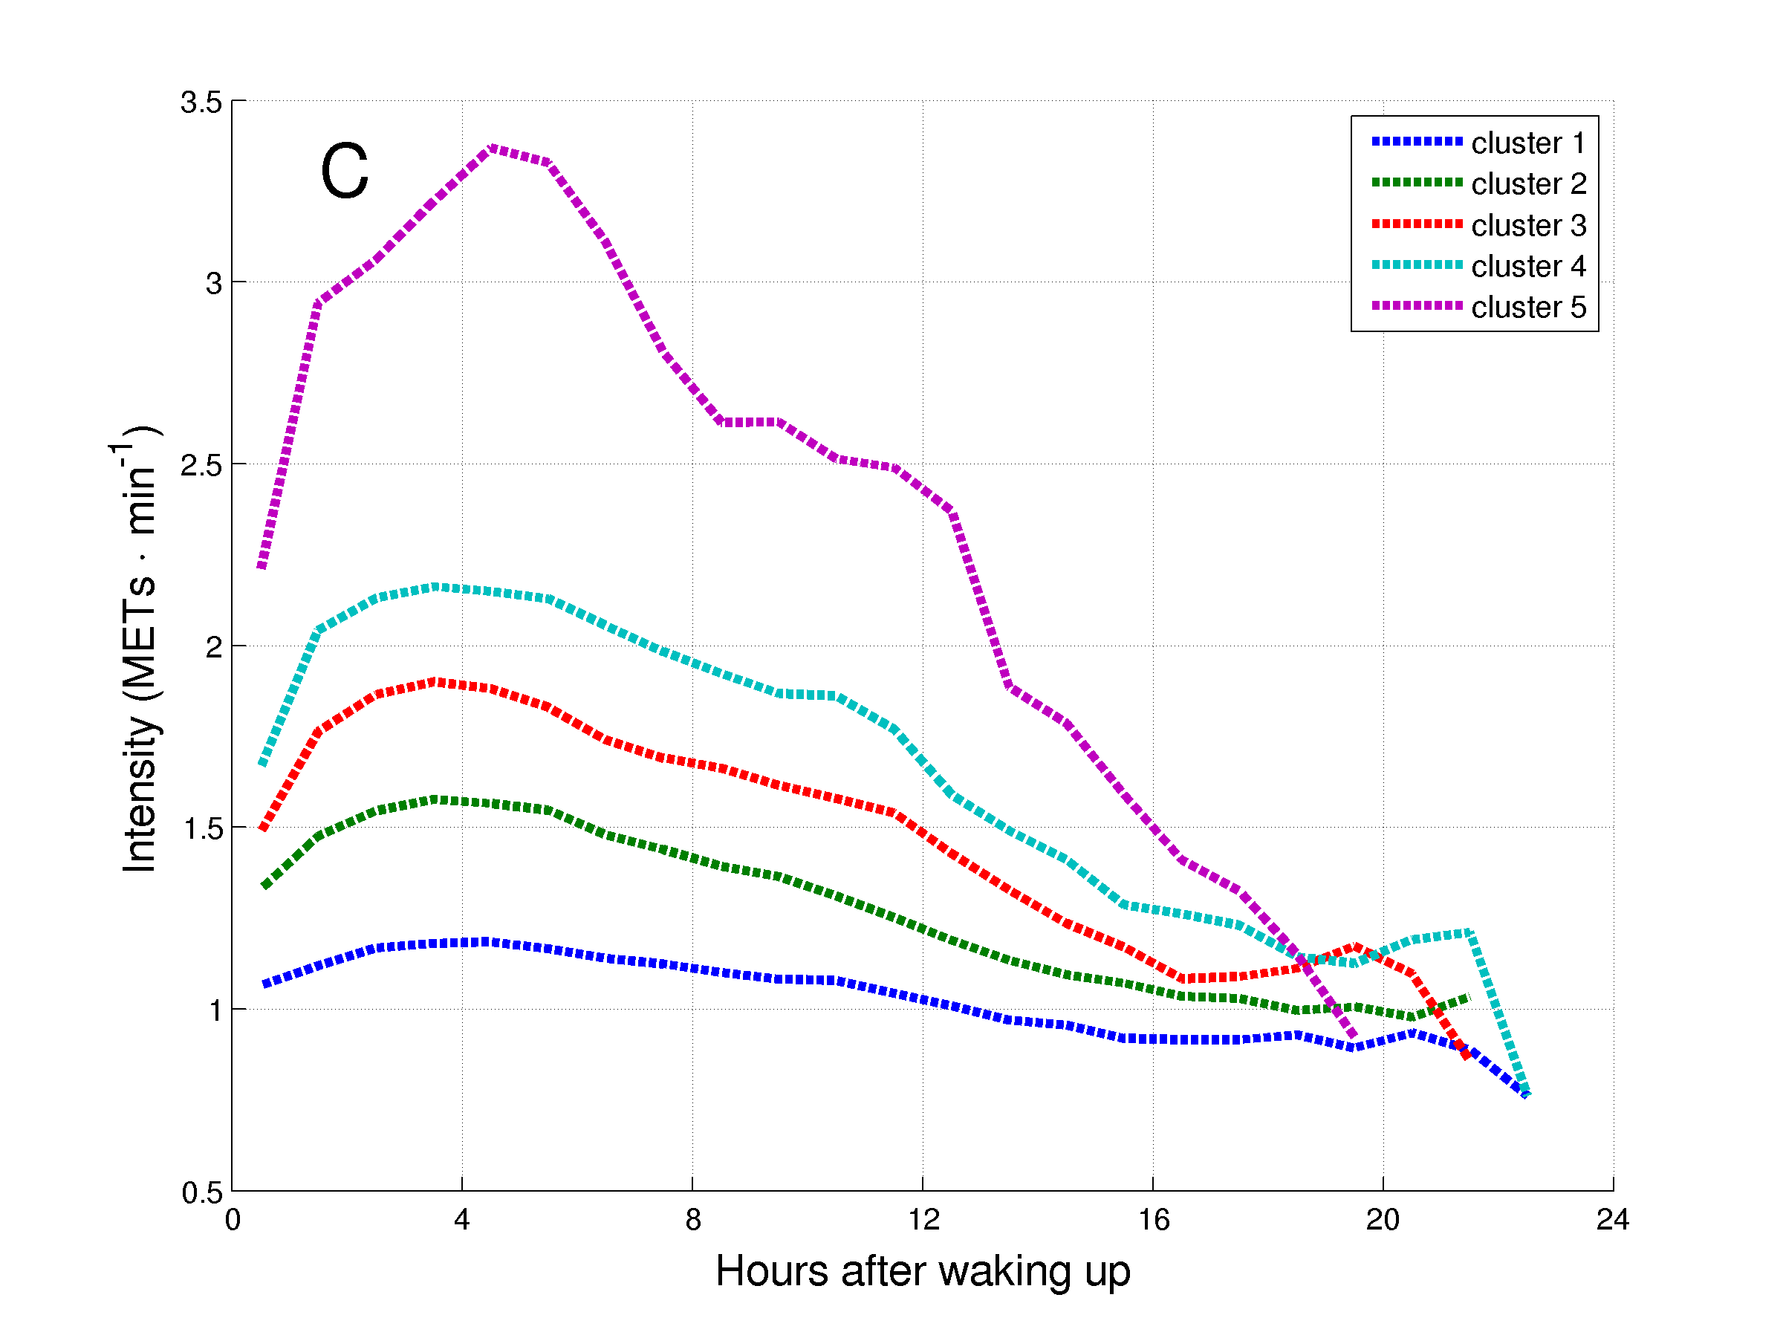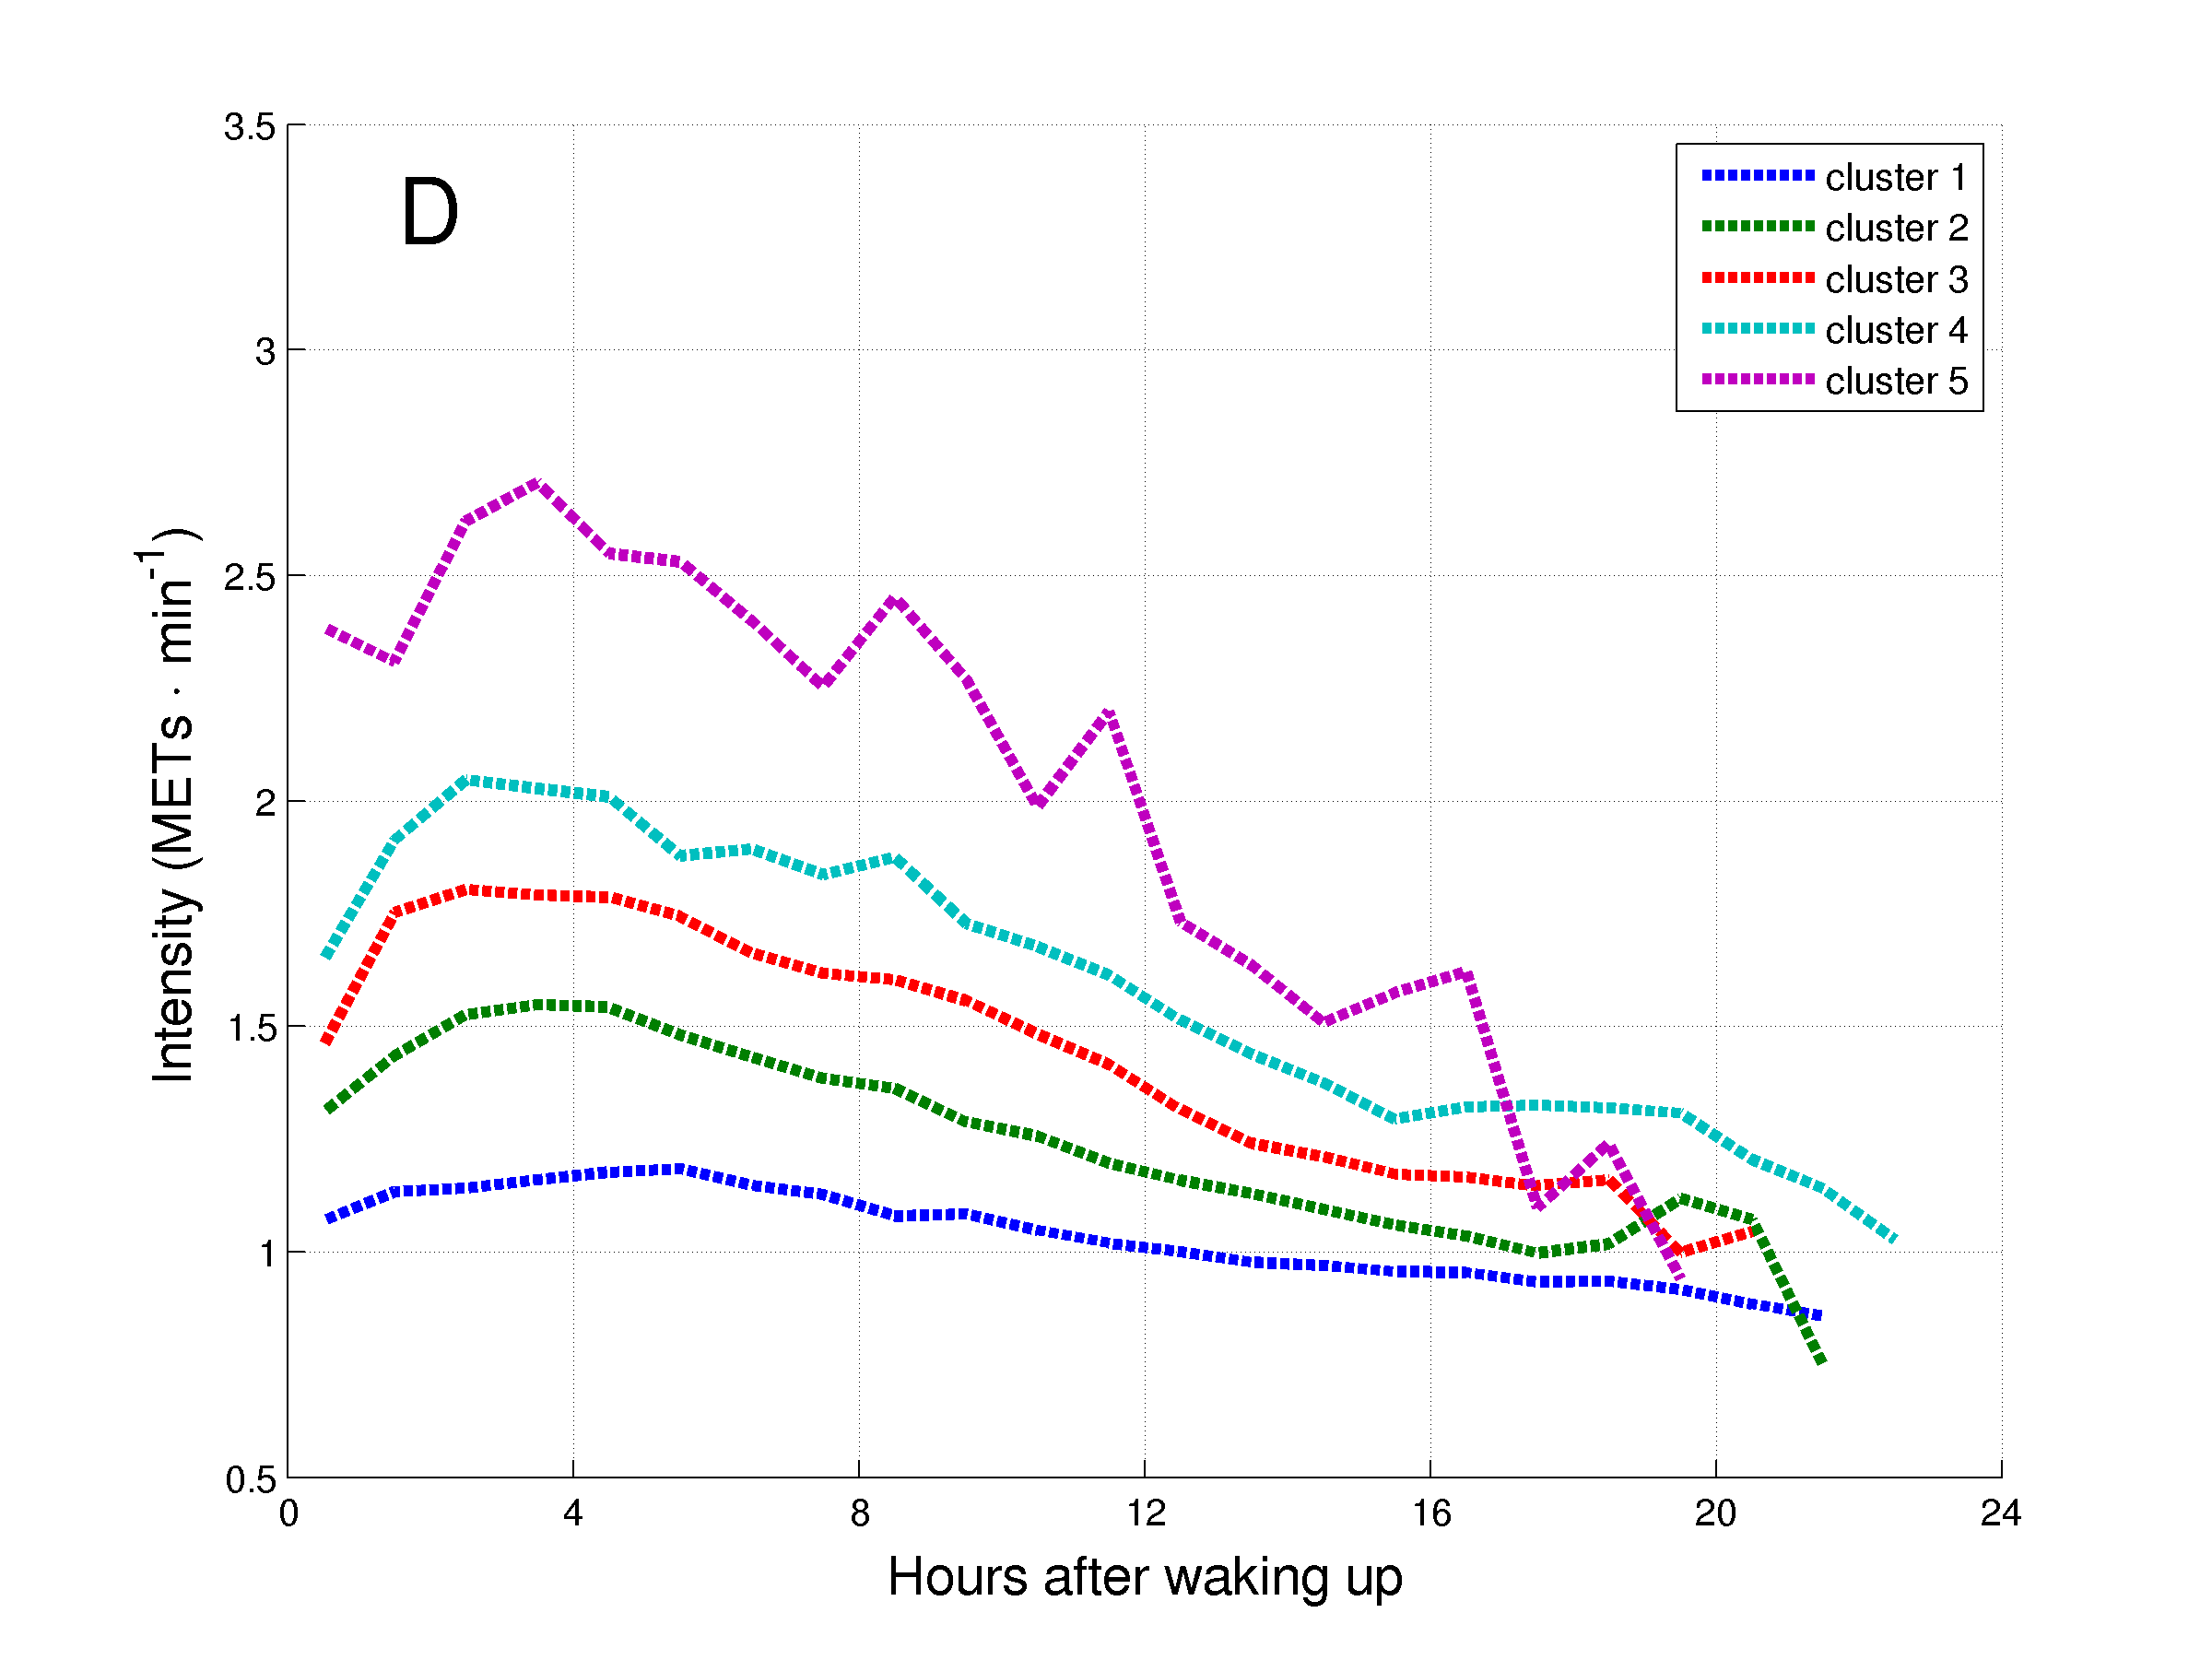
Figure 6. Daily hourly pattern of the clusters of patients with COPD during weekdays (A and C) and weekend days (B and D), and before (A and B) and after (C and D) synchronization of the waking up moment.

